

**Software Design Description**

**ST{AU}CKTION**

**Team 10**

**Ahmet Oğuz Ergin, 21903070**

**Ayşe Özge Erkan, 21902107**

**Bertan Özer, 21902475**

**Damla Köklü, 22003189**

**Göktuğ Yeşilyurt, 22003697**

Bilkent University

Department of Information Systems and Technologies

08.01.2025

Change History

|  |  |  |  |  |
| --- | --- | --- | --- | --- |
| **File Name** | **Document Type** | **Deliverable** | **Version** | **Submission Date** |
| Team10_SDD_FR1.docx | MS Word 2021 | 4 | 1 | 08.01.2025 |

Project Team

|  |  |  |
| --- | --- | --- |
| **Name, Surname** | **Student Id Number** | **e-mail** |
| Ahmet Oğuz Ergin | 21903070 | oguz.ergin@ug.bilkent.edu.tr |
| Ayşe Özge Erkan | 21902107 | ozge.erkan@ug.bilkent.edu.tr |
| Bertan Özer | 21902475 | bertan.ozer@ug.bilkent.edu.tr |
| Damla Köklü | 22003189 | damla.koklu@ug.bilkent.edu.tr |
| Göktuğ Yeşilyurt | 22003697 | goktug.yesilyurt@ug.bilkent.edu.tr |

Project Details

|  |  |
| --- | --- |
| **Project Name** | **ST{AU}CKTION** |
| **Software Name** | **ST{AU}CKTION** |
| **Company Name** | **No Sponsor Company** |
| **Academic Advisor** | **Dr. Cüneyt Sevgi** |
| **Github URL** | **https://github.com/staucktion** |
| **WEB page** |  |

Individual Contributions Overview

|  |  |
| --- | --- |
| **Name, Surname** | **Summary of Contributions to the SDD Document** |
| Ahmet Oğuz Ergin | Main responsible of the Analysis Model & Planning section. |
| Ayşe Özge Erkan | Main responsible of 4 Use Cases (U18, U20, BU3, BU4) of Low-Level Design section. |
| Bertan Özer | Co-responsible of the High-Level (Architechture) Design section. |
| Damla Köklü | Co-responsible of the High-Level (Architechture) Design section. |
| Göktuğ Yeşilyurt | Main responsible of the Executive Summary, Scope sections, 4 Use Cases (U14, U17, BU1, BU2) of Low-Level Design section and formatting of the document. |

Executive Summary

The Software Design Description (SDD) for the ST{AU}CKTION project outlines the architectural strategies, detailed design components, and technical methodologies adopted for developing a platform that facilitates photo auctions. This document captures how different architectural paradigms, including Client-Server, Event-Driven, and Microservice architectures, were selected and implemented to meet the unique functional and non-functional requirements of the system. Each architectural choice is aligned with specific system components, such as geotagged photo uploads, watermarked previews, real-time auction functionalities, and secure financial transactions. The SDD includes detailed workflows for critical use cases such as "Take Photo," "Upload Photo," and "Purchase Now." Supporting design artifacts, including UML diagrams, pseudocode, and sequence workflows, provide a granular view of how the system operates and interacts. Non-functional requirements, such as a maximum response time of 2 seconds for 95% of requests and the ability to handle 200 simultaneous users, have been thoroughly addressed through performance optimization techniques like caching, database indexing, and containerized deployments. The document also highlights the technologies used, including React, Node.js, PostgreSQL, and AWS Lambda, chosen for their scalability and efficiency. The design emphasizes security, with measures like JWT authentication, TLS encryption, and SHA-256 password hashing ensuring robust data protection. Verification and validation strategies outlined in the SDD include unit, integration, and system testing, with tools such as Postman, Mocha, and SonarQube aiding in quality assurance. These processes ensure both the functional correctness and structural soundness of the system. Additionally, acceptance testing with stakeholders and iterative feedback loops reinforce alignment with project requirements. This SDD not only serves as a technical guide for implementation but also as a reference for ensuring that the final product is scalable, maintainable, and aligned with user needs and project objectives. It underscores the team’s commitment to building a secure, efficient, and user-friendly platform.[1]

Table of Contents

**ii**

1 Scope 1

2 Analysis Model & Planning 1

3 High-Level (Architecture) Design 44

4 Low Level Design 63

U14 – Purchase Now 63

U17 – Manage Watermarked Photo 65

U18 – Take Photo 66

U20 - Upload Photo 70

BU1 – Check Balance 74

BU2 – Make Transaction 77

BU3 – Log Actions 81

BU4 – Manage Provision 82

5 Discussions 87

5.1 Limitations and Constraints 87

5.2 Health and Safety Issues 87

5.3 Legal Issues 87

5.4 Economic Issues and Constraints 87

5.5 Sustainability 87

5.6 Ethical Issues 87

5.7 Multidisciplinary Collaboration 87

6 References 88

List of Tables

**iii**

Table 1 - Incremental Implementation of Use Cases 3

Table 2 - Work Breakdown Structure [1] 23

List of Figures

**iv**

Figure 1 - Use Case Diagram of Bank Simulation 1

Figure 2 - Use Case Diagram of St{au}cktion 2

Figure 3 - UML Block Diagram 47

Figure 4 - EER Diagram 48

Figure 5 - UML Deployment Diagram 53

Figure 6 - U14 Pseudo Code 63

Figure 7 - U14 UML Activity Diagram 64

Figure 8 - U14 UML Sequence Diagram 64

Figure 9 - U14 UML Class Diagram 65

Figure 10 - U18 Pseudo Code 67

Figure 11 - U18 UML Activity Diagram 68

Figure 12 - U18 UML Sequence Diagram 69

Figure 13 - U18 UML Class Diagram 70

Figure 14 - U20 Pseudo Code 71

Figure 15 - U20 UML Activity Diagram 72

Figure 16 - U20 UML Sequence Diagram 73

Figure 17 - U20 UML Class Diagram 74

Figure 18 - BU1 Pseudo Code 75

Figure 19 - BU1 UML Activity Diagram 76

Figure 20 - BU1 UML Sequence Diagram 76

Figure 21 - BU1 UML Class Diagram 77

Figure 22 - BU2 Pseudo Code 78

Figure 23 - BU2 UML Activity Diagram 79

Figure 24 - BU2 UML Sequence Diagram 80

Figure 25 - BU2 UML Class Diagram 81

Figure 26 - BU4 Pseudo Code 83

Figure 27 - BU4 UML Activity Diagram 84

Figure 28 - BU4 UML Sequence Diagram 85

Figure 29 - BU4 UML Class Diagram 86

Abbreviations

|  |  |
| --- | --- |
| API | Application Programming Interface |
| AWS | Amazon Web Services |
| BA | Bank Actor |
| BU | Bank Use Case |
| EP | Epic |
| FR | Functional Requirement |
| JSON | JavaScript Object Notation |
| JWT | JSON Web Token |
| MUI | Material UI |
| NPV | Net Present Value |
| NReq | Non Functional Requirement |
| SDD | Software Design Description |
| SHA | Secure Hash Algorithm |
| SRS | Software Requirements Specification |
| TLS | Transport Layer Security |
| U | Use Case |
| UI | User Interface |
| UML | Unified Modeling Language |
| WBS | Work Breakdown Structure |

# Scope

The Software Design Description (SDD) outlines the architectural and detailed design components essential for the development of ST{AU}CKTION, a platform enabling photographers and stock image companies to engage in photo auctions. This project focuses on creating a system that integrates geotagged photo uploads, watermarked previews, dynamic voting mechanisms, and real-time auction processes. The scope of the SDD includes the following:

1. **System Architecture**: The design leverages a combination of architectural paradigms tailored to specific functionalities:
   * **Client-Server Architecture**: Facilitates secure and efficient communication between the web and mobile interfaces and the backend server. This model ensures smooth data exchange for user management, auctions, and photo operations.
   * **Event-Driven Architecture**: Supports real-time interactions within the mobile app, particularly in location-based photo management and event-triggered workflows like GPS-based photo uploads.
   * **Microservice Architecture**: The banking module operates as an independent microservice, enabling secure, scalable, and modular handling of financial transactions.
2. **Detailed Use Case Design**: The SDD includes comprehensive design for critical functionalities:
   * **Geotagged Photo Management**: Users can capture and upload geotagged photos with watermarks applied automatically to ensure intellectual property protection.
   * **Auction and Voting Mechanisms**: Dynamic processes enable users to vote on photos and participate in monthly auctions with secure fund provisions.
   * **Financial Transactions**: Secure APIs facilitate account management, bidding payments, and fund returns for unsuccessful bids.
3. **Technologies and Tools**: The design incorporates modern technologies to ensure scalability, maintainability, and robust performance:
   * **Backend Technologies**: Node.js and ExpressJS power the backend APIs, while PostgreSQL serves as the primary database for structured data.
   * **Frontend Frameworks**: React and MUI are utilized for a responsive, user-friendly interface, complemented by Redux for state management.
   * **Cloud and Deployment**: AWS Lambda and Docker provide scalability and efficiency for intensive operations like watermarking and photo storage.
4. **Non-Functional Requirements**: The SDD addresses key performance and quality benchmarks:
   * **Performance Goals**: The system is designed to handle 200 simultaneous users with response times under 2 seconds for 95% of requests.
   * **Security Standards**: Measures such as TLS encryption, JWT-based authentication, and SHA-256 password salting ensure data integrity and secure transactions.
   * **Scalability**: The use of containerized deployments ensures consistent performance across diverse environments and simplifies future scaling.
5. **Verification and Validation**: The design provides a roadmap for ensuring system quality:
   * **Testing Strategies**: Unit, integration, and system testing are outlined for validating individual modules, inter-component interactions, and overall functionality.
   * **Compliance**: Non-functional requirements like fault tolerance and availability are addressed through modular architecture and automated recovery mechanisms.
6. **Ethical and Sustainable Practices**: The team has adopted digital collaboration tools like GitHub and Zoom to minimize environmental impact and ensure remote-friendly workflows. Sustainability and ethical considerations are embedded in the development approach, reflecting the team’s commitment to responsible innovation.

This SDD provides a detailed blueprint for translating functional and non-functional requirements into a robust, maintainable, and scalable software product. It serves as a guiding document for the development team, ensuring clarity and alignment with project objectives.[2]

# Analysis Model & Planning

1. **Functional Requirements**
2. **Use Case Diagrams**

This section presents the updated Use Case Diagrams for two projects, the Bank Simulation and St{au}cktion.

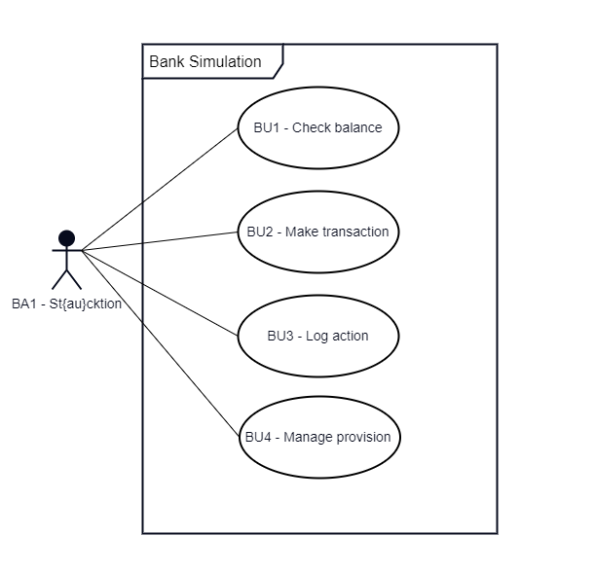

Figure 1 - Use Case Diagram of Bank Simulation

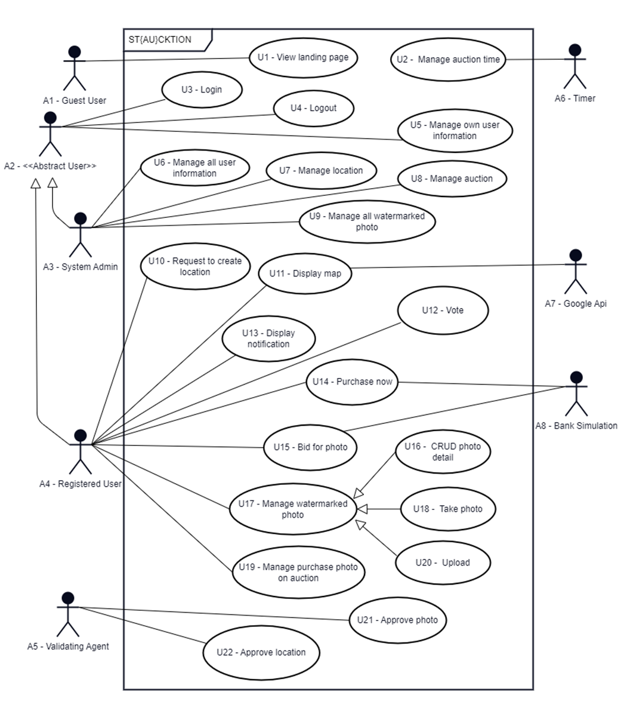

Figure 2 - Use Case Diagram of St{au}cktion

The table below shows which use case will be implemented in each increment.

Table 1 - Incremental Implementation of Use Cases

|  |  |  |  |
| --- | --- | --- | --- |
| Increment | 1st Increment | 2nd Increment | 3rd Increment |
| Use Case ID | BU1, BU2, BU3, BU4, U14, U17, U18, U20 | U1, U3, U4, U5, U6, U7, U8, U9, U16 | U2, U10, U11, U12, U13, U15, U19, U21, U22 |

1. **Functional Requirements**

**Epics**

**EP-1:** Authentication and authorization

**EP-2:** User management

**EP-3:** Location management

**EP-4:** Photo management

**EP-5:** Auction management

**EP-6:** Purchase management

**EP-7:** Simulated Bank management

**EP-8:** Notification management

**EP1:**

**FR-1.0:**

**Description:** The system shall display an image slider along with "Register" and "Login" buttons on the landing page for guest users.

**Acceptance Criteria:** The image slider, "Register" and "Login" buttons are visible and functional for guest users.

**FR-2.0:**

**Description:** The system shall allow guest users to register by entering their information and clicking the "Register" button.

**Input:** Guest user enters required information and clicks "Register."

**Output:** User is directed to the home page.

**Acceptance Criteria:**

* Guest user is successfully redirected to the home page after registration.

**FR-2.1:**

**Description:** The system shall validate user input during the registration process.

**Input:**

* User type: Radio button with 2 values as photographer and stock image company, required.
* Name: Up to 32 alphabetic characters, required.
* Surname: Up to 32 alphabetic characters, required.
* Email: Must be in a valid email format, required, unique.
* Password: Must be at least 8 characters long up to 32, contain at least one uppercase letter, one lowercase letter, one digit, and one special character (e.g., @, #, $, %), required.
* Phone number: Must consist of 10 digits, required.
* Credit card information: Must follow standard credit card format (e.g., 16 digits, valid expiration date, CVV), required.

**Output:**

* Success color for valid inputs
* Error color for invalid inputs.

**Acceptance Criteria:**

* All fields must accept only the specified formats and lengths.
* Valid inputs are visually indicated with a success color.
* Invalid inputs are visually indicated with an error color and display error message.
* Users cannot proceed with registration until all inputs are valid.

**FR-3.0:**

**Description:** The system shall allow guest users to authenticate via token by entering their credentials and clicking the "Login" button.

**Input:** Guest user enters required login information and clicks the "Login" button.

**Output:** User is directed to the home page upon successful authentication.

**Acceptance Criteria:**

* Guest user is successfully authenticated with valid credentials.
* User is directed to the home page after successful login.
* Appropriate error message is displayed for invalid credentials.

**FR-4.0:**

**Description:** The system shall display home page to registered users.

**Acceptance Criteria:**

* Home page visible to registered users.
* Guest users do not have access to the home page.

**FR-5.0:**

**Description:** The system shall log out registered users upon their request.

**Acceptance Criteria:**

* Registered users are logged out when they click the "Logout" button, and the system redirects them to the landing page.
* After successful logout, pages require authentication shouldn’t be available.

**EP-2:**

**FR-6.0:**

**Description:** The system shall display an app bar at the top of the page with a user icon.

**Acceptance Criteria:** App bar shows user icon.

**FR-7.0:**

**Description:** The system shall direct registered users to the user information page upon clicking the user icon on appbar.

**Input:** Registered user clicks the user icon on the app bar.

**Output:** The user's own information page is displayed.

**Acceptance Criteria:** Registered users are directed to the user information page when they click the user icon on the app bar.

**FR-8.0:**

**Description:** The system shall allow the system administrator to view a list of all registered users.

**Input:** System administrator accesses the user management section of the system.

**Output:** A list of all registered users, including relevant details (e.g., username, email), is displayed.

**Acceptance Criteria:** The system administrator can access and view a comprehensive list of all registered users in the user management section.

**FR-9.0:**

**Description:** The system shall allow the system administrator to update information for any registered user.

**Input:** System administrator selects a user from the user management section and modifies the user’s profile information.

**Output:** The updated user information is saved and displayed for the selected user.

**Acceptance Criteria:** The system administrator can successfully update any registered user’s information, and the system reflects the changes immediately upon saving.

**FR-10.0:**

**Description:** The system shall allow the system administrator to delete a registered user.

**Input:** System administrator selects a user from the user management section and confirms the delete action.

**Output:** The selected user is permanently removed from the system, and the user no longer appears in the user list.

**Acceptance Criteria:** The system administrator can successfully delete a registered user, and the user is removed from all relevant records.

**FR-11.0:**

**Description:** The system shall display user’s own information to registered user.

**Input:** Registered user clicks the user icon on the app bar.

**Output:** The user's personal information is presented accurately on the information page without password field. There are also buttons for update delete account.

**Acceptance Criteria:** Registered users are directed to the user information page when they click the user icon on the app bar.

**FR-12.0:**

**Description:** The system shall allow registered users to update their own user information.

**Output:** The updated user information is saved and displayed.

**Acceptance Criteria:** Registered users can successfully update their profile information, and the system reflects the changes immediately upon saving.

**EP-3:**

**FR-13.0:**

**Description:** The system shall allow the system administrator to remove location categories to ensure accuracy and enforce policies.

**Input:** System administrator accesses the location management section and selects a location category to remove.

**Output:** The selected location category is permanently removed from the system.

**Acceptance Criteria:** The system administrator can successfully delete a location category, and it no longer appears in the location categories list.

**FR-14.0:**

**Description:** The system shall allow the validating agent to approve location category requests to ensure they are accurate and appropriate.

**Input:** Validating agent reviews a pending location category request and selects the option to approve it.

**Output:** The approved location category is added to the system and made available to users.

**Acceptance Criteria:** The validating agent can successfully approve location category requests, and approved categories are immediately added to the list of available location categories.

**FR-15.0:**

**Description:** The system shall allow registered users to request the creation of a new location category for photo uploads.

**Input:** Registered user submits a request to create a new location category during the photo upload process if the desired category does not already exist.

**Output:** The system records the request for a new location category and forwards it for validation by an authorized agent.

**Acceptance Criteria:** Registered users can submit requests for new location categories during photo upload, and the request is successfully forwarded for validation.

**FR-16.0:**

**Description:** The system shall allow registered users to display a map with location category markers that can be clicked to view and vote on watermarked photos.

**Input:** Registered user accesses the map and clicks on a location category marker.

**Output:** The system displays watermarked photos associated with the selected location category.

**Acceptance Criteria:** Registered users can view location category markers on the map, click on a marker to see associated watermarked photos, and vote on the displayed photos.

**EP-4:**

**FR-17.0:**

**Description:** The admin shall manage all watermarked photos to ensure proper control, monitoring, and enforcement of policies regarding their display and sale.

**Input:** The system administrator accesses the photo management interface.

**Output:** The system displays a list of all watermarked photos, allowing the administrator to review, approve, update, or remove them as necessary.

**Acceptance Criteria:** The system administrator can view and manage all watermarked photos, including taking actions to enforce display and sale policies, ensuring photos are appropriately handled and monitored.

**FR-18.0:**

**Description:** The system shall allow a validating agent to approve photos so that they can be included in the auction and made available for stock image companies to bid on.

**Input:** The validating agent accesses the photo approval interface and reviews submitted photos.

**Output:** Approved photos are added to the auction pool, while rejected photos are flagged for further review or removal.

**Acceptance Criteria:** The validating agent can approve or reject photos, with only approved photos being included in the auction, ensuring they meet the necessary criteria for auction eligibility.

**FR-19.0:**

**Description:** The system shall allow photographers to take a photo using the system's user interface with GPS enabled to ensure the photo's location cannot be mimicked.

**Input:** The photographer accesses the system's camera interface and enables the GPS function.

**Output:** The system captures the photo and records the GPS coordinates of the location where the photo was taken.

**Acceptance Criteria:** The system ensures that the photo is taken using the system’s interface with the GPS location data embedded, preventing the photo’s location from being spoofed or altered.

**FR-20.0:**

**Description:** The system shall allow photographers to upload only the photo they have taken, which will automatically be watermarked and placed in the auction for stock image companies to bid on.

**Input:** The photographer takes a photo directly through the system’s interface.

**Output:** The taken photo is automatically watermarked and added to the auction pool for stock image companies to bid on.

**Acceptance Criteria:** The system ensures that only the taken photo is uploaded, automatically watermarked, and made available for bidding once the watermark is applied.

**FR-21.0:**

**Description:** The system shall allow photographers to manage their uploaded photos so that they can, delete, or review them before they are included in the auction.

**Input:** The photographer accesses the photo management interface to view their uploaded photos.

**Output:** The system provides options to update, delete, or review the details of the uploaded photos.

**Acceptance Criteria:** Photographers can successfully view, update, delete, or review their uploaded photos, with any changes reflected before the photos are included in the auction.

**FR-22.0:**

**Description:** The system shall allow registered users to display watermarked photos using a location filter so that they can view photos based on specific geographic areas.

**Input:** The registered user selects a location filter within the system's photo display interface.

**Output:** The system displays watermarked photos that match the selected geographic area.

**Acceptance Criteria:** The system successfully filters and displays watermarked photos based on the location criteria selected by the registered user, allowing them to view photos from specific geographic areas.

**FR-23.0:**

**Description:** The system shall allow photographers to vote for watermarked photos uploaded by other users.

**Input:** The photographer selects a watermarked photo uploaded by another user and casts a vote.

**Output:** The system records the vote and associates it with the photo for potential inclusion in the auction.

**Acceptance Criteria:** Photographers can successfully vote for other users' photos, and if the photo is selected in the auction, the photographer earns money.

**EP-5:**

**FR-24.0:**

**Description:** The system shall allow photographers to upload photos from the 1st to the 10th of each month.

**Input:** The uploaded photo is added to the system for voting once the upload period ends.

**Output:** The uploaded photo is added to the system for voting once the upload period ends.

**Acceptance Criteria:** The system only accepts photo uploads from photographers between the 1st and the 10th of each month.

**FR-25.0:**

**Description:** The system shall allow users to vote on the uploaded photos from the 10th to the 20th of each month.

**Input:** A registered user selects a photo to vote for from the uploaded photos.

**Output:** The selected photo’s vote count is updated accordingly.

**Acceptance Criteria:** Users can vote on photos only between the 10th and 20th of each month, and the vote count is updated in real-time.

**FR-26.0:**

**Description:** The system shall automatically start the auction from the 20th of each month and end it on the 1st of the following month for photos that have been voted on.

**Input:** The system detects the current date and identifies photos eligible for auction.

**Output:** The auction starts automatically at midnight on the 20th of each month and ends at midnight on the 1st of the following month.

**Acceptance Criteria:** The system successfully initiates the auction on the 20th and closes it on the 1st of the following month without manual intervention, ensuring consistent monthly auctions.

**FR-27.0:**

**Description:** The system shall allow the system administrator to terminate auctions to ensure policy compliance and prevent inappropriate situations.

**Input:** The system administrator accesses the auction management interface and reviews ongoing auctions for policy violations.

**Output:** The auction is terminated if it is found to have inappropriate content or violates policies.

**Acceptance Criteria:** The system administrator can terminate auctions.

**FR-27.1:**

**Description:** The system shall refund any paid provision to the user if an auction is terminated by the system administrator.

**Input:** The system administrator terminates an auction due to a policy violation or inappropriate content.

**Output:** The provision paid by the user is automatically refunded to their account.

**Acceptance Criteria:** When an auction is terminated by the system administrator, any provision paid by the stock image company is refunded to their account.

**FR-28.0:**

**Description:** The system shall allow stock image companies to place bids on the top 10% voted watermarked photos during an auction, with the provision to be paid upfront.

**Input:** A stock image company selects a top 10% voted watermarked photo and places a bid through the auction interface, paying the required provision upfront.

**Output:** The bid is recorded along with the provision payment, and the company's bid is considered in the auction for the selected photo.

**Acceptance Criteria:** Stock image companies can place bids on watermarked photos that are in the top 10% of voted photos, and the provision is paid upfront before the bid is placed.

**FR-28.1:**

**Description:** The system shall update the provision value of a photo in the auction when a new bid is placed by another stock image company, lowering the provision amount.

**Input:** A new bid is placed on a top 10% voted watermarked photo by a stock image company.

**Output:** The provision value for the photo is adjusted downward to reflect the new bid.

**Acceptance Criteria:** When a new bid is placed, the system automatically adjusts the provision value of the photo accordingly, ensuring that the new bid’s provision is factored in and reducing the previous value.

**FR-29.0:**

**Description:** The system shall grant the original photo to the stock image company that places the highest bid in the auction when the auction ends.

**Input:** The auction ends, and the system evaluates the highest bid placed by the stock image companies.

**Output:** The stock image company with the highest bid is awarded the original photo for purchase.

**Acceptance Criteria:** The system automatically identifies the highest bid in the auction, and the stock image company that placed it is granted the original photo once the auction concludes.

**FR-29.1:**

**Description:** The system shall deduct the provisioned value from the stock image company's balance when an image is sold in the auction.

**Input:** The auction ends, and the stock image company with the highest bid wins the original photo.

**Output:** The provisioned value is deducted from the stock image company's account balance.

**Acceptance Criteria:** When a photo is sold, the system automatically deducts the provisioned value from the winning stock image company's balance, ensuring the payment is processed successfully.

**FR-30.0:**

**Description:** The system shall distribute a total 10% commission from the payment of the stock image company to the photographer who successfully votes for a photo in the top 10% of voted photos.

**Input:** A stock image company completes a purchase of a photo that was voted into the top 10%, and a photographer votes for that photo.

**Output:** The photographer who voted for the top 10% photo receives the total 10% commission from the stock image company’s payment.

**Acceptance Criteria:** The system identifies the photographer who voted for the top 10% photo, calculates the 10% commission from the stock image company’s payment, and distributes the full commission to the photographers.

**FR-30.1:**

**Description:** The system shall retain a 20% commission from the payment made by the stock image company for each successful photo purchase.

**Input:** A stock image company completes the payment for a purchased photo at the end of the auction.

**Output:** The system automatically deducts and retains a 20% commission from the total payment.

**Acceptance Criteria:** Upon a successful transaction, the system calculates and retains 10% of the total payment from the stock image company, ensuring the commission is deducted and not paid to the photographer.

**FR-30.2:**

**Description:** The system shall distribute 70% of the payment from the stock image company to the photographer who took the purchased photo.

**Input:** A stock image company completes the purchase of a specific photo through the auction.

**Output:** The photographer who took the photo receives 70% of the payment amount from the stock image company’s purchase.

**Acceptance Criteria:** Upon a successful purchase, the system automatically transfers 70% of the payment to the photographer who took the photo.

**FR-31.0:**

**Description:** The system may retain copies of sold photos and display them with a watermark, including information such as the sale price.

**Input:** A photo is successfully sold through the auction.

**Output:** The sold photo is stored in the system and displayed with a watermark indicating details such as the amount paid by the stock image company.

**Acceptance Criteria:** After a photo is sold, the system retains a watermarked copy with sale information (e.g., sale price), which can be displayed in a gallery or records.

**EP-6:**

**FR-32.0:**

**Description:** The system shall allow photographers to assign a monetary value to their photos, if the photos are not in the top 10% of votes.

**Input:** The photographer accesses their photo portfolio and selects a photo to assign a value. They enter the desired monetary value into the provided input field.

**Output:** The system updates the photo’s details to include the assigned value, making it visible to stock image companies.

**Acceptance Criteria:**

* Photographers can assign a monetary value to any photo in their portfolio.
* The assigned value is saved and displayed alongside the photo for stock image companies to view.

**FR-33.0:**

**Description:** The system shall allow stock image companies to view photos that are not in the top 10% of votes.

**Input:** Photographer accesses photos that are not in the top 10% of votes.

**Output:** The system displays a list of photos not in the top 10% of votes, along with assigned monetary value.

**Acceptance Criteria:** The system provides an option for stock image companies to filter and view only photos that are not in the top 10% of votes, along with their assigned monetary values.

**FR-33.1:**

**Description:** The system shall allow stock image companies to purchase photos that are not in the top 10% of votes.

**Input:** The stock image company selects a photo from the gallery of non-top 20% photos and initiates the purchase process by clicking a button.

**Output:** The system processes the payment, removes the watermark from the purchased photo, and grants the company access to download the high-resolution version.

**Acceptance Criteria:** The system successfully processes the payment and provides the stock image company with access to the purchased photo without the watermark.

**FR-34.0:**

**Description:** The system shall display an indicator to show that a photo has already been sold.

**Input:** Registered user views the gallery of photos after purchasing one.

**Output:** The system marks the purchased photo with a "Sold" label or icon in the gallery view.

**Acceptance Criteria:** The system visibly marks photos as "Sold" after purchase, ensuring other users are aware they are no longer available for sale.

**EP-7:**

**FR-35.0:**

**Description:** The system shall allow users to check their account balance.

**Input:** The user requests to check their current balance.

**Output:** The system displays the current balance of the user's account.

**Acceptance Criteria:** The system must display the correct current balance whenever the user requests it, with updates reflecting all transactions.

**FR-36.0:**

**Description:** The system shall allow users to make a transaction from their account.

**Input:** The user specifies the transaction details (e.g., amount, recipient).

**Output:** The system processes the transaction and updates the account balance accordingly.

**Acceptance Criteria:** The transaction is successfully processed, and the account balance is updated immediately after the transaction is completed.

**FR-37.0:**

**Description:** The system shall log all transactions performed by the user for record-keeping and auditing purposes.

**Input:** The user makes a transaction.

**Output:** The system records transaction details (date, time, type, amount, balance) in a transaction log.

**Acceptance Criteria:** Every transaction is logged accurately, and the log is accessible for auditing or review by authorized users.

**FR-38.0:**

**Description:** The system shall apply provisions to accounts or transactions.

**Input:** A transaction is initiated by the user.

**Output:** The system applies the appropriate provision to the transaction or account based on predefined conditions.

**Acceptance Criteria:** Provisions are correctly applied during transactions, and account balances are updated accordingly.

**EP-8:**

**FR-39.0:**

**Description:** The system will notify stock image companies when an auction is terminated by the system administrator.

**Input:** The system administrator terminates an auction.

**Output:** The system display notification on the system.

**Acceptance Criteria:** Users receive relevant notifications promptly when related events occur, ensuring they are informed of important actions or updates.

**FR-40.0:**

**Description:** The system will notify the photographer, stock image company, and voters of a photo when it is sold in the auction.

**Input:** A photo is sold in the auction.

**Output:** Notifications are sent to the photographer, the stock image company, and all voters of the photo.

**Acceptance Criteria:** The photographer, stock image company, and voters of the photo receive timely notifications when the photo is sold, ensuring all relevant parties are informed of the sale.

1. **Non-Functional Requirements**
2. **Usability Requirements**

**NReq1.0:** 3 out of 5 new users, representing diverse personas, shall complete key user experience tasks such as updating profile information, uploading a photo and reviewing a photo within 5 minutes, using no more than 10 GUI interactions (e.g., pressing buttons or selecting values from dropdown menus).

**NReq1.1:** 3 out of 5 experienced users who have experience with system at least 8 hours, representing diverse persona, shall complete key user experience tasks such as updating profile information, uploading a photo and reviewing a photo within 2 minutes, using no more than 10 GUI interactions (e.g., pressing buttons or selecting values from dropdown menus).

**NReq2.0:** 3 out of 5 new users, should report a satisfaction level of at least 3 out of 5 after completing key user tasks, such as updating profile information, uploading a photo and reviewing a photo.

**NReq2.1:** 3 out of 5 experienced users who have experience with system at least 8 hours, should report a satisfaction level of at least 4 out of 5 after completing key user tasks, such as updating profile information, uploading a photo and reviewing a photo.

1. **Performance Requirements**

**Capacity Requirements**

**NReq3.0:** 200 simultaneous users shall reach all services.

**Dynamic Requirements**

**NReq4.0:** Web user interface documents should be rendered within 2 seconds under normal workload conditions 95% of the time.

**NReq5.0:** The Web API shall respond to text-based requests within 700ms under normal workload conditions, 95% of the time.

1. **Software System Attributes**

**Reliability**

**NReq6.0:** System shall experience no more than 2 level-one faults per month.

**NReq6.1:** System shall experience no more than 5 level two faults per month.

**Availability**

**NReq7.0:** The system architecture shall replace failed system modules with healthy ones automatically.

**Security**

**NReq8.0:** Data transactions using tokens should be secured with the HS256 algorithm for integrity.

**NReq9.0:** Server service ports shall not be exposed to the public.

**NReq10.0:** Web services should be secured with TLS and RSA encryption, utilizing SHA-256 to protect against attacks such as man-in-the-middle.

**NReq11.0:** System shall use a salting technique as SHA-256 to keep user passwords secure.

**Maintainability**

**NReq12.0:** The average time for a maintenance engineer to repair a severity-2 defect shall be no greater than 8 person-hours.

**Portability**

**NReq13.0:** Web software modules shall be designed to be run on Windows, MacOS, Linux operating systems, ensuring a high degree of flexibility when porting to alternative environments.

**NReq14.0:** The application shall be developed in a proven portable programming language to enhance compatibility across various operating systems.

**NReq15.0:** Web applications shall be deployed using containerization so that it achieves consistent performance across various environments, enhances scalability by allowing for rapid deployment and scaling of application instances, isolates components to prevent failures from affecting the entire system, and simplifies maintenance and management through integration with container orchestration tools.

1. **Constraints**

**NReq16.0:** Web applications shall be implemented using TypeScript.

**NReq17.0:** The map shall be displayed using the Google Maps API.

1. **Error Handling Requirements**

**User Errors**

**NReq18.0:** System shall warn user to non-critical user errors. Such as input text value to numeric input field.

**External System Errors**

**NReq19.0:** System shall log noncritical external system errors. Such as cannot display map.

**NReq20.0:** System shall log critical external system errors. Such as monetary transaction fail.

**Developer Errors**

**NReq21.0:** System shall log errors and aim to avoid crashing the entire system.

1. **Other Non-Functional Requirements**

**External Interfaces**

**NReq22.0:** System shall communicate with Bank API to be able to perform monetary transactions.

1. **Software Increments**

Table 2 - Work Breakdown Structure [1]

|  |  |  |  |  |  |  |  |  |  |  |  |
| --- | --- | --- | --- | --- | --- | --- | --- | --- | --- | --- | --- |
|  | **Breakdown St{au}cktion** | **Description** | **WBS** | **Code** | **Dependencies** | **Assigned to** | | | | | **PH** |
|  |  |  |  | **1.0** |  |  |  |  |  |  |  |
|  |  | **Initial Plan + Business** **Model** |  | **1.1** |  |  |  |  |  |  |  |
|  | WP1.1 | Deciding on Internal Stakeholders (Role Assessment). | 1.1.1 |  | 0 | Ahmet | Ayşe | Bertan | Damla | Göktuğ | 5ph |
|  | WP1.2 | Meeting with PO (Cüneyt Sevgi) for creating a use case diagram of St{au}cktion. | 1.1.2 |  | 0 | Ahmet | Ayşe | Bertan | Damla | Göktuğ | 5ph |
|  | WP1.3 | Discussing requirements, project scope and assessing risks. | 1.1.3 |  | 0 |  | Ayşe |  |  |  | 3ph |
|  | WP1.4 | Allocating tasks on the Initial Plan report and Business Model. | 1.1.4 |  | 0 | Ahmet | Ayşe | Bertan | Damla | Göktuğ | 5ph |
|  | WP1.5 | Creating a GANTT Chart. | 1.1.5 |  | WP1.4,1.3,1.2 |  |  |  | Damla |  | 8ph |
|  | WP1.6 | Creating Work Breakdown Structure. | 1.1.6 |  | WP1.4,1.3,1.2 |  |  |  | Damla |  | 8ph |
|  | WP1.7 | Discussing the Legal, Ethical, Health constraints while preparing this project. | 1.1.7 |  | WP1.6,1.5,1.4,1.3,1.2,1.1 | Ahmet | Ayşe | Bertan | Damla | Göktuğ | 5ph |
|  | WP1.8 | Getting feedback about first draft of the initial plan document. | 1.1.8 |  | WP1.6,1.5,1.4,1.3,1.2 | Ahmet | Ayşe | Bertan | Damla | Göktuğ | 5ph |
|  | WP1.9 | Creating a change list for the initial plan document. | 1.1.9 |  | WP1.6,1.5,1.4,1.3,1 | Ahmet | Ayşe | Bertan | Damla | Göktuğ | 10ph |
|  | WP1.10 | Changing the initial plan’s final document considering those changes. | 1.1.10 |  | WP1.9 | Ahmet | Ayşe | Bertan | Damla | Göktuğ | 20ph |
|  | WP1.11 | Formatting the final document | 1.1.11 |  | WP1.10 |  |  |  | Damla |  | 24ph |
|  |  | **SRS + Requirements Prototype** |  | **1.2** |  |  |  |  | Damla |  |  |
|  | WP2.1 | Choosing the Requirements, Creating a requirements prototype. | 1.2.1 |  | Deliverable 1 | Ahmet | Ayşe | Bertan | Damla | Göktuğ | 5ph |
|  | WP2.2 | Allocating tasks on the SRS + Requirements prototype. | 1.2.2 |  | Deliverable 1 | Ahmet | Ayşe | Bertan | Damla | Göktuğ | 4ph |
|  | WP2.3 | Finalizing the expected end software products list with identifying database operations that will be used | 1.2.3 |  | Deliverable 1 |  |  |  | Damla | Göktuğ | 12ph |
|  | W2.P4 | Defining the final version of the functional and non functional requirements. | 1.2.4 |  | Deliverable 1 | Ahmet |  |  |  |  | 8ph |
|  | WP2.5 | Creating the use case models. | 1.2.5 |  | Deliverable 1 | Ahmet |  |  |  |  | 8ph |
|  | WP2.6 | Discussing the two most complex use cases with the product owner. | 1.2.6 |  | WP2.5,2.4 | Ahmet | Ayşe | Bertan | Damla | Göktuğ | 10ph |
|  | WP2.7 | Defining system models. | 1.2.7 |  | WP2.5,2.4 |  | Ayşe |  |  |  | 8ph |
|  | WP2.8 | Identifying user characteristics. | 1.2.8 |  | WP2.5,2.4 |  | Ayşe |  |  |  | 4ph |
|  | WP2.9 | Getting feedback about first draft of the initial plan document. | 1.2.9 |  | WP2.1,2.2,2.3,2.4,2.5,2.6,2.7 | Ahmet | Ayşe | Bertan | Damla | Göktuğ | 5ph |
|  | WP2.10 | Creating a change list for the SRS document. | 1.2.10 |  | WP2.9 | Ahmet | Ayşe | Bertan | Damla | Göktuğ | 10ph |
|  | WP2.11 | Changing the initial plan’s final document considering those changes. | 1.2.11 |  | WP2.10 | Ahmet | Ayşe | Bertan | Damla | Göktuğ | 20ph |
|  | WP2.12 | Formatting the final document. | 1.2.12 |  | WP2.11 | Ahmet |  |  |  |  | 12ph |
|  |  | **SPMP** |  | **1.3** |  |  |  |  |  |  |  |
|  | WP3.1 | Estimating effort, making a  schedule. | 1.3.1 |  | Deliverable 2 | Ahmet | Ayşe | Bertan | Damla | Göktuğ | 10ph |
|  | WP3.2 | Defining all of the cash flows in the project from start to the end, and calculating the NPV. | 1.3.2 |  | Deliverable1,2 | Ahmet |  |  | Damla |  | 20ph |
|  | WP3.3 | Updating the work-breakdown structure. | 1.3.3 |  | Deliverable 1,2 |  |  |  | Damla |  | 12ph |
|  | WP3.4 | Working on project monitoring structure and Measuring. | 1.3.4 |  | Deliverable 2 |  | Ayşe |  |  |  | 5ph |
|  | WP3.5 | Determining final Development Environment, and resources. | 1.3.5 |  | Deliverable 2 |  |  |  |  | Göktuğ | 10ph |
|  | WP36 | Identifying the test cases. | 1.3.6 |  | Deliverable 2 |  |  | Bertan |  |  | 8ph |
|  | WP3.7 | Going to the course instructor’s room for getting an idea about the work breakdown structure. | 1.3.7 |  | WP,3.4,3.5,3.6 |  |  |  | Damla |  | 10ph |
|  | WP3.8 | Getting feedback about SRS document. | 1.3.8 |  | WP3.4,3.5,3.6 | Ahmet | Ayşe | Bertan | Damla | Göktuğ | 5ph |
|  | WP3.9 | Creating a change list for the SRS document. | 1.3.9 |  | WP3.8 | Ahmet | Ayşe | Bertan | Damla | Göktuğ | 10ph |
|  | WP3.10 | Changing the SRS final document considering those changes. | 1.3.10 |  | WP3.9 | Ahmet | Ayşe | Bertan | Damla | Göktuğ | 20ph |
|  | WP3.11 | Getting feedback about first draft of the initial plan document. | 1.3.11 |  | WP3.10 | Ahmet | Ayşe | Bertan | Damla | Göktuğ | 5ph |
|  | WP3.12 | Formatting the final document. | 1.3.12 |  | WP3.11 |  | Ayşe |  |  |  | 18ph |
|  |  | **SDD** |  | **1.4** |  |  |  |  |  |  |  |
|  | WP4.1 | Finalizing the Use case diagram and Requirements, using the latest version of them. | 1.4.1 |  | Deliverable 2,3 | Ahmet |  |  |  |  | 8ph |
|  | WP4.2 | Finalizing, or updating software increment descriptions in SPMP. | 1.4.2 |  | Deliverable 3 | Ahmet |  |  |  |  | 5ph |
|  | WP4.3 | Mentioning about the frameworks, APIs, libraries, services, and databases that will be used, and explaining how they will contribute to the project. | 1.4.3 |  | Deliverable 3 |  |  |  |  | Göktuğ | 5ph |
|  | WP4.4 | Making high level architecture design. | 1.4.4 |  | Deliverable 3 |  |  | Bertan | Damla |  | 6ph |
|  | WP4.5 | Making low level design. | 1.4.5 |  | Deliverable 3 |  | Ayşe |  |  |  | 6ph |
|  | WP4.6 | Go over the document for making sure the informations are correct and will be helpful for developing the project. | 1.4.6 |  | WP4.4,4.5 | Ahmet | Ayşe | Bertan | Damla | Göktuğ | 5ph |
|  | WP4.7 | Discuss the document with PO, and project advisor Cüneyt Sevgi for making sure the document is highlighting the coding stage clearly. | 1.4.7 |  | Wp4.4,4.5,4.6 | Ahmet | Ayşe | Bertan | Damla | Göktuğ | 5ph |
|  | WP4.8 | Getting feedback about first draft of the SDD report. | 1.4.8 |  | WP4.1,4.2,4.3,4.4,4.5,4.6,4.7 | Ahmet | Ayşe | Bertan | Damla | Göktuğ | 5ph |
|  | WP4.9 | Creating a change list for SDD’s final document. | 1.4.9 |  | WP4.8 | Ahmet | Ayşe | Bertan | Damla | Göktuğ | 10ph |
|  | WP4.10 | Changing the SDD’s final document considering those changes. | 1.4.10 |  | WP4.9 | Ahmet | Ayşe | Bertan | Damla | Göktuğ | 10ph |
|  | WP4.11 | Formatting the final document. | 1.4.11 |  | WP4.10 |  |  |  |  | Göktuğ | 6ph |
|  |  | **1st Increment Product + Presentation** |  | **1.5** |  |  |  |  |  |  |  |
|  | WP5.1 | Discuss the First Increment product’s requirements with the PO. | 1.5.1 |  | 0 | Ahmet | Ayşe | Bertan | Damla | Göktuğ | 5ph |
|  | WP5.2 | Allocating tasks of developers and lead roles. | 1.5.2 |  | Deliverable 1 | Ahmet | Ayşe | Bertan | Damla | Göktuğ | 10ph |
|  | WP5.3 | Designing, and writing the code of taking the photo operation. | 1.5.3 |  | WP5.2 | Ahmet | Ayşe | Bertan | Damla | Göktuğ | 40ph |
|  | WP5.4 | Designing and writing the codes for storing the taken photos. | 1.5.4 |  | WP5.3 | Ahmet |  |  |  | Göktuğ | 50ph |
|  | WP5.5 | Generating watermark for photos that are validated. | 1.5.5 |  | 0 | Ahmet |  |  |  |  | 30ph |
|  | WP5.6 | Generate another requirements report for the coding stage. | 1.5.6 |  | 0 |  | Ayşe |  | Damla |  | 20ph |
|  | WP5.7 | Testing First Increment Product. | 1.5.7 |  | WP5.3,5.4,5.5,5.6 |  |  | Bertan |  |  | 10ph |
|  | WP5.8 | Preparing a presentation about 1st Increment Product. | 1.5.8 |  | WP5.7 | Ahmet | Ayşe | Bertan | Damla | Göktuğ | 50ph |
|  | WP5.9 | Presenting the 1st Increment Product. | 1.5.9 |  | WP5.8 | Ahmet | Ayşe | Bertan | Damla | Göktuğ | 5ph |
|  |  | **1st Sprint** |  | **1.6** |  |  |  |  |  |  |  |
|  | WP6.1 | Designing the user interfaces for the project. | 1.6.1 |  | 0 |  | Ayşe |  | Damla |  | 60ph |
|  | WP6.2 | Creating the host DBMS. | 1.6.2 |  | 0 |  |  |  |  | Göktuğ | 50ph |
|  | WP6.3 | Developing a website as Prototype. | 1.6.3 |  | 0 | Ahmet | Ayşe | Bertan | Damla | Göktuğ | 70ph |
|  | WP6.4 | Allowing users to register to the system. | 1.6.4 |  | 0 | Ahmet |  |  |  |  | 40ph |
|  | WP6.5 | Allowing users to login and logout to the system. | 1.6.5 |  | 0 | Ahmet |  |  |  |  | 18ph |
|  | WP6.6 | Allowing system admin to manage user information. | 1.6.6 |  | 0 |  |  |  | Damla |  | 20ph |
|  | WP6.7 | Allowing registered users to manage their own information. | 1.6.7 |  | 0 |  |  |  | Damla |  | 20ph |
|  | WP6.8 | Implementing the API for accessing the map information. | 1.6.8 |  | 0 |  |  |  |  | Göktuğ | 50ph |
|  | WP6.9 | Allowing System admin to manage location categories. | 1.6.9 |  | 0 |  | Ayşe |  |  |  | 50ph |
|  | WP6.10 | Managing location information while users are taking photo, and send upload request. | 1.6.10 |  | 0 |  | Ayşe |  |  |  | 50ph |
|  | WP6.11 | Sending the photos to the validating agent for verification before uploading the images. | 1.6.11 |  | 0 |  |  |  |  | Göktuğ | 50ph |
|  | WP6.12 | Meeting with PO (Cüneyt Sevgi) for ensuring the project is going according to the plan. | 1.6.12 |  | 0 | Ahmet | Ayşe | Bertan | Damla | Göktuğ | 30ph |
|  | WP6.13 | Testing, Verification, and validation of the project. | 1.6.13 |  | 0 |  |  | Bertan |  |  | 20ph |
|  |  | **2nd Sprint** |  | **1.7** |  |  |  |  |  |  |  |
|  | WP7.1 | Allowing photographers to to take photos using the system’s user interface, while location is on. | 1.7.1 |  | 0 |  | Ayşe |  |  |  | 40ph |
|  | WP7.2 | Allowing validating agent to approve the location category requests. | 1.7.2 |  | 0 |  |  |  |  | Göktuğ | 40ph |
|  | WP7.3 | Allowing users to request a new location category. | 1.7.3 |  | 0 |  |  | Bertan |  |  | 40ph |
|  | WP7.4 | Using Google API for the application’s map that includes the location categories. | 1.7.4 |  | 0 |  |  |  |  | Göktuğ | 30ph |
|  | WP7.5 | Allowing registered users to vote for the photos in the relevant location categories. | 1.7.5 |  | 0 |  |  |  | Damla |  | 30ph |
|  | WP7.6 | Allowing photographers to update, delete and manage their photos. | 1.7.6 |  | 0 |  |  |  | Damla |  | 40ph |
|  | WP7.7 | Meeting with PO (Cüneyt Sevgi) for ensuring the project is going according to the plan. | 1.7.7 |  | 0 | Ahmet | Ayşe | Bertan | Damla | Göktuğ | 30ph |
|  | WP7.8 | Working on the mobile side of the application. | 1.7.8 |  | 0 | Ahmet | Ayşe | Bertan | Damla | Göktuğ | 100ph |
|  | WP7.9 | Creating the simulated banking application. | 1.7.9 |  | 0 |  | Ayşe |  | Damla |  | 40ph |
|  | WP7.10 | Testing, Verification, and validation of the Simulated banking application. | 1.7.10 |  | 0 |  |  | Bertan |  |  | 30ph |
|  | WP7.11 | Testing, Verification, and validation of the project. | 1.7.11 |  | 0 |  |  | Bertan |  |  | 20ph |
|  |  | **3rd Sprint** |  | **1.8** |  |  |  |  |  |  |  |
|  | WP8.1 | Creating a auction functionality for images that are voted the highest. | 1.8.1 |  | 0 |  |  |  |  | Göktuğ | 50ph |
|  | WP8.2 | Selling photos to the person who put the highest bid. | 1.8.2 |  | 0 |  |  |  |  | Göktuğ | 20ph |
|  | WP8.3 | Allowing application to manage bids. | 1.8.3 |  | 0 |  |  |  |  | Göktuğ | 20ph |
|  | WP8.4 | Putting a timer for the auction. | 1.8.4 |  | 0 | Ahmet |  |  |  |  | 30ph |
|  | WP8.5 | Enabling the selling option for images that are not selected for the auction. | 1.8.5 |  | 0 |  |  |  | Damla |  | 40ph |
|  | WP8.6 | Testing of the bidding functionality. | 1.8.6 |  | 0 |  |  | Bertan |  |  | 30ph |
|  | WP8.7 | Testing, Verification, and validation of the Entire project. | 1.8.7 |  | 0 | Ahmet | Ayşe | Bertan | Damla | Göktuğ | 200ph |
|  | WP8.8 | Getting ready for the Jury. Presentation and full code coverage. | 1.8.8 |  | Deliverable 5,6,7 | Ahmet | Ayşe | Bertan | Damla | Göktuğ | 100ph |
|  | WP8.9 | Buying some sweat treats for people visiting the project presentation. | 1.8.9 |  | WP8.8 | Ahmet | Ayşe | Bertan | Damla | Göktuğ | 5ph |
|  | WP8.10 | Proposing the project to the Jury and the PO (Cüneyt Sevgi). | 1.8.10 |  | WP8.10 | Ahmet | Ayşe | Bertan | Damla | Göktuğ | 60ph |

1. **Frameworks, Libraries, Services, Databases and APIs**

**First Increment**

**React:** For developing the front-end user interface.

**MUI:** For designing a responsive and modern UI with pre-built components.

**Vite:** For fast and efficient build and bundling of the React application.

**npm:** For managing JavaScript dependencies.

**Node:** For building the backend server.

**Redux:** For managing global state on the front-end.

**Axios:** For making API requests between the front-end and the backend.

**ExpressJS:** For building the backend API.

**Prisma:** For ORM integration to manage database queries and migrations.

**PostgreSQL:** For storing application data in a relational database.

**pgAdmin:** For managing and visualizing the PostgreSQL database.

**PostgreSQL client:** For interacting with the PostgreSQL database programmatically.

**Docker:** For containerizing the application for consistent development and deployment.

**Mocha:** For writing and running API automation test tests.

**Mochawesome:** For generating detailed, attractive test reports from Mocha tests.

**Postman:** For testing API endpoints manually and running tests during development.

**Second Increment**

**JWT:** For implementing secure authentication and authorization in the application.

**Traefik:** For routing traffic and setting up a reverse proxy/load balancer.

**Third Increment**

**AWS**: For hosting and managing cloud infrastructure, including services like EC2 for hosting.

# High-Level (Architecture) Design

1. **Selected Architecture**

*Client-Server*

Client-Server architecture is a model where a client sends data requests to a server, which processes these requests and responds back to the client. This architecture will be used in both the frontend and backend components of the system. For the frontend, this model ensures smooth communication between the web interface and the server, making it easier to tie the two components together while enabling efficient data exchange for key operations such as user login, auction updates, and photo management. On the backend, it centralizes business logic and data processing, supporting secure API communication and efficient handling of database interactions. This design meets key non-functional requirements, such as usability (NReq1.0–2.1), performance (NReq4.0–5.0), and security (NReq8.0–11.0).

Advantages:  
 One of the major advantages of using a client-server architecture is the clear separation of responsibilities between the client and server, which simplifies debugging and maintenance. Additionally, this model scales effectively when paired with containerization and cloud hosting solutions (e.g., Docker and AWS Lambda), as outlined in portability requirements (NReq13.0–15.0).

Disadvantages:  
 A key disadvantage is the potential for bottlenecks on the server, especially under heavy loads, which could impact performance. Furthermore, the architecture relies heavily on a robust and consistent network connection to ensure smooth operation, which may pose a challenge in environments with poor connectivity.

*Event Driven Architecture*

Event-Driven Architecture is a model where the flow and behavior of the system are determined by events, such as user actions, system-generated notifications, or external triggers. This architecture will be utilized in the Androidcomponent, which heavily relies on the phone's GPS/location services and camera. For example, GPS generates events whenever there are location updates, enabling the app to categorize photos based on location. Similarly, the camera triggers events when a photo is captured, initiating workflows like watermarking and uploading. These features make event-driven architecture a natural fit for the Android app, ensuring real-time responsiveness and alignment with usability goals (NReq1.0–2.1) and performance requirements (NReq4.0).

Advantages**:**  
 The event-driven design enables the app to respond dynamically to real-time user interactions, providing a seamless experience. Additionally, its modular structure simplifies debugging and maintenance by decoupling event handlers, which supports maintainability goals (NReq12.0).

Disadvantages**:**  
 The asynchronous nature of event-driven systems can make debugging more complex. Designing and managing event handlers also requires additional development overhead, increasing the complexity of implementation.

*Microservice Architecture*

The Banking System will be implemented as a microservice within the larger architecture of the application. It is designed as an independent, self-contained service to simulate financial transactions. This allows it to interact with other components of the system, such as the auction service or user management module, with the usage of APIs. By isolating the banking functionality, the system ensures modularity, maintainability, and scalability.

This design meets critical non-functional requirements, including security (NReq8.0–11.0) by encrypting sensitive data and securing API endpoints, and reliability (NReq6.0–7.0) by isolating financial operations to prevent system-wide faults. The microservice approach also aligns with maintainability (NReq12.0), as updates to the banking module can be made independently of other system components.

Advantages:  
 As a microservice, the banking system is decoupled from the rest of the application, allowing it to be developed, tested, deployed, and scaled independently. This modular approach ensures that any issues within the banking system do not directly affect the other parts of the system. Additionally, by adhering to a microservices pattern, the system remains flexible and can accommodate future extensions or more complex banking logic if needed.

Disadvantages:  
 While the microservices approach offers flexibility and isolation, it introduces additional complexity in managing inter-service communication and deployment. Additionally, integration testing across multiple services becomes more complex.

*Monolithic*

Monolithic Architecture is a traditional software design where all components of the application are tightly integrated into a single codebase. This architecture will be used for the project at large, which encompasses functionalities like auctions, user management, and photo handling. The monolithic structure allows for faster development and deployment, making it well-suited for the initial stages of the project. By centralizing all operations, this design simplifies debugging and ensures cohesive performance across the app. It aligns with maintainability requirements (NReq12.0) in the short term and supports performance goals (NReq4.0–5.0).

**Advantages:**  
 Monolithic architecture is simpler to implement and deploy, making it ideal for smaller teams and projects with tight deadlines. The unified codebase also facilitates debugging and testing, ensuring consistent functionality across all components.

**Disadvantages:**  
 As the system grows in complexity, the tightly integrated nature of a monolith can make scaling and refactoring difficult. Additionally, future transitions to distributed architectures (e.g., microservices) may require significant reengineering efforts.

1. **Logical View**

The **St{au}cktion Block Diagram** illustrates the system architecture, showcasing its components and their interactions. The application has two primary user interfaces: the **Web Interface**, accessed via browsers, and the **Android Mobile Interface**, allowing users to perform core actions like authentication, photo uploads, bidding, and purchasing photos. The backend, powered by **Node.js**, acts as the central processing unit, managing user requests, interacting with external services, and handling data storage.

The system integrates with external APIs like **Google Maps API**, for verifying the geolocation of uploaded photos, and **Banking Simulation API**, for securely processing payments. **PostgreSQL** serves as the relational database, storing structured data such as user profiles, photo metadata, bids, and transaction records. Photo storage and processing are handled by **AWS Lambda**, which performs tasks like watermarking, and the **Storage Server**, where processed photos are securely stored.

Administrative functionalities are provided through the **Admin Panel**, for managing user accounts and configurations, and the **Validator Panel**, for validating photos before publication. The data flow ensures secure communication: user interfaces interact with the backend via HTTPS, which then communicates with databases, APIs, and storage services using reliable protocols. This architecture ensures scalability, security, and efficiency for seamless user experiences and robust system performance.[3]

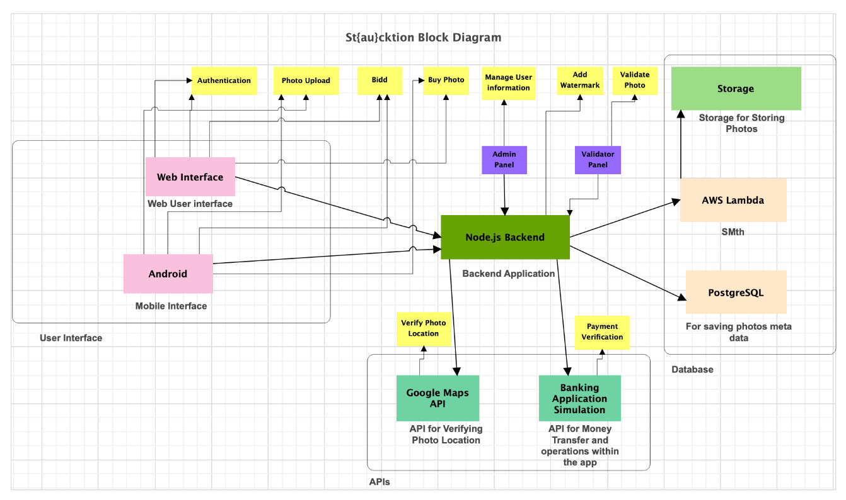

Figure 3 - UML Block Diagram

The EER Diagram is shown in the below table.

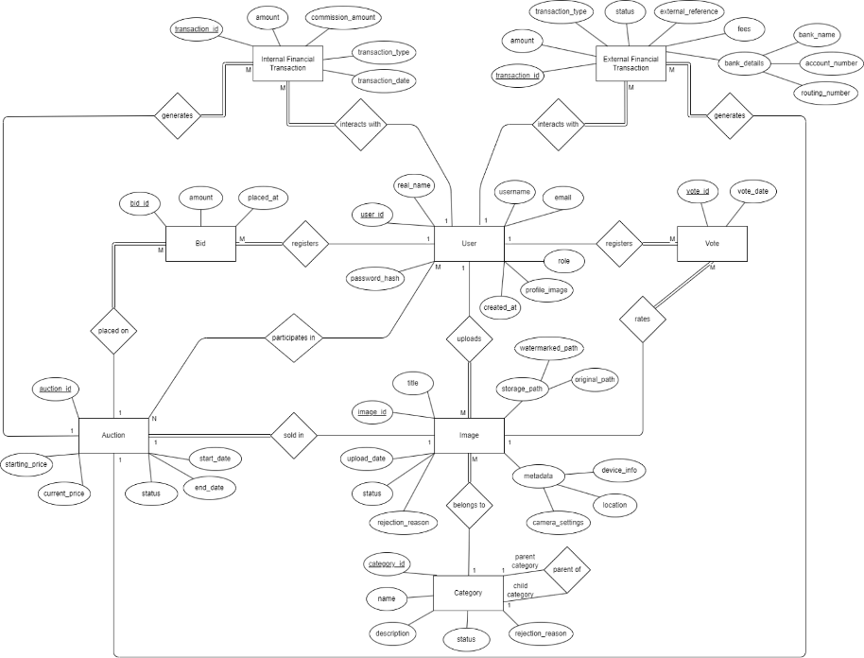

Figure 4 - EER Diagram

1. **Process View**

*U14 – Purchase now*

The Purchase Now use case allows a user to approve the purchase of a watermarked photo through a seamless interaction between the frontend and backend components. The process begins when the user selects a watermarked photo displayed in the FileUpload component and clicks the "Purchase Now" button. This action triggers the sendApproveMail function within the FileUpload component, which sends a POST request to the backend's “/mail/send” endpoint via the MailEndpoint. The MailEndpoint forwards this request to the MailFacade, which handles email-related operations. The MailFacade first validates the request using MailValidation, ensuring that all required data, such as the photo name, action ("Approve Purchase"), and email, are present and correctly formatted. Once validated, the MailFacade invokes the MailService, which is responsible for sending the actual email to the provided address.

After successfully sending the email, the MailService returns a confirmation to the MailFacade, which in turn sends a success response back to the MailEndpoint. The MailEndpoint passes this response to the frontend, where the FileUpload component processes it and displays a success alert to the user, confirming that the photo purchase approval email was sent. This use case demonstrates the integration of frontend and backend components, ensuring that the user can efficiently approve photo purchases with real-time feedback on the action's success.

*U17 – Manage watermarked photo*

The "Manage Watermarked Photos" use case allows a client to upload photos for watermarking and retrieve watermarked photos. The client begins by sending a POST “/photo/upload” request to the PhotoEndpoint, along with the photo file. The PhotoEndpoint processes the photo upload using Multer and forwards the details to the PhotoFacade. The PhotoFacade manages the business logic for watermarking and calls the PhotoService to apply the watermark to the uploaded photo. The PhotoService processes the photo, applies the watermark, and saves it to the FileSystem. Once the photo is saved, the PhotoService returns the path of the watermarked photo to the PhotoFacade, which sends it back to the PhotoEndpoint. The PhotoEndpoint responds to the client with the watermarked photo’s URL. Additionally, clients can retrieve a list of all watermarked photos by sending a GET /photo/list request to the PhotoEndpoint, which forwards the request to the PhotoFacade. The PhotoFacade calls the PhotoService, which retrieves the list of photos from the FileSystem and returns it to the client. This use case ensures efficient management of photos, from watermarking to retrieval.

*U18 – Take photo*

The "Capture Photo" use case allows a user to capture a photo using the device’s camera. When the user clicks the "Take Photo" button in the MainActivity, the system calls the onClick(View v) event handler, which triggers the startActivityForResult() method to launch the CameraActivity. In CameraActivity, the system prepares an Intent with the action MediaStore.ACTION_IMAGE_CAPTURE and a secure file URI generated via FileProvider.getUriForFile(). This intent is passed to the camera app, prompting the user to capture a photo. Once the photo is captured, the camera app saves it to the specified file path in the app’s private storage.After saving the photo, the camera app returns a result (RESULT_OK) to the CameraActivity via the onActivityResult() method, along with the file path of the captured image. The CameraActivity then passes this result back to MainActivity, completing the photo capture process. This use case ensures that photos are securely captured and stored for further use.

*U20 - Upload*

The "Upload Photo" use case allows a user to upload a captured photo to the server. Once the photo capture process is complete, MainActivity sends the file path of the captured photo to ApiActivity through an explicit Intent. In ApiActivity, the photo is prepared for upload by creating a MultipartBody.Part object. The system initializes the RetrofitClient using the getInstance() method, which sets up the base URL and networking configurations. The RetrofitClient then creates an instance of the ApiService interface through the create(ApiService.class) method.The ApiService handles the photo upload by calling the uploadPhoto() method, which sends the photo as a POST /upload request to the server. The server processes the uploaded photo, stores it, and sends a success response back to ApiService. This response is passed back to ApiActivity, which updates the user interface to inform the user of the upload's success or failure. This use case ensures that photos are securely and efficiently uploaded to the server.

*BU1 – Check balance*

The "Check Balance" use case is designed to allow a client to retrieve their account balance securely. The client initiates this use case by sending a POST “/accounts“ request with their card details (card number, expiration date, and CVV) to the BankEndpoint, which acts as the entry point for the system. The BankEndpoint forwards the request to the BankFacade, which is responsible for handling business logic. The BankFacade then validates the card details by interacting with the BankValidation component to ensure the request is complete and correct. Upon successful validation, the BankFacade requests the account information from the BankService, which queries the Database to fetch the associated account details, including the balance. The Database returns the account information to the BankService, which forwards it to the BankFacade. Finally, the BankFacade sends the account balance to the BankEndpoint, which responds to the client with the requested information. This flow ensures secure validation, data retrieval, and accurate communication between all components.

*BU2 – Make transaction*

The "Make Transaction" use case facilitates secure fund transfers between two accounts. The client initiates this process by sending a POST “/transactions” request to the BankEndpoint, including details of the sender, recipient, and the amount to be transferred. The BankEndpoint forwards the request to the BankFacade, which handles the business logic. The BankFacade validates the transaction details by calling the BankValidation component to ensure the sender has sufficient balance and the account details are correct. Upon validation, the BankFacade instructs the BankService to execute the transaction. The BankService interacts with the Database to update the balances of both the sender and recipient accounts and log the transaction. Once the transaction is successfully recorded, the Database sends confirmation to the BankService, which returns the success response to the BankFacade. The BankFacade relays this response to the BankEndpoint, which communicates the result back to the client. This use case ensures secure and reliable execution of financial transactions between accounts.

*BU3 – Log action*

The "Log Action" use case allows a client to retrieve audit logs that track actions performed within the system. This process begins when the client sends a GET “/auditlogs” request to the BankEndpoint. The BankEndpoint forwards this request to the BankFacade, which manages the business logic for retrieving audit logs. The BankFacade communicates with the BankService to fetch the logs stored in the Database. The BankService queries the Database to retrieve all available audit log entries. Once the logs are retrieved, the Database returns them to the BankService, which sends them to the BankFacade. The BankFacade then forwards the logs to the BankEndpoint, which sends the list of audit logs back to the client. This use case provides an effective way to track and review system activities, ensuring transparency and accountability.

*BU4 – Manage provision*

The "Manage Provision" use case allows a client to add or remove financial provisions from their account. For adding a provision, the client sends a PUT “/provisions/add “request to the BankEndpoint with the required details. The BankEndpoint forwards the request to the BankFacade, which manages the logic for provision handling. The BankFacade validates the request by interacting with the BankValidation component to ensure the account has sufficient balance for the provision. After validation, the BankFacade calls the BankService to update the provision in the Database. The Database updates the provision details and returns confirmation to the BankService, which reports the success to the BankFacade. The BankFacade then sends a success response to the BankEndpoint, which responds to the client. For removing a provision, the process is similar, except the client sends a PUT “/provisions/remove” request, and the system ensures that the provision amount is valid and can be removed. This use case ensures secure management of account provisions while maintaining data consistency.

1. **Physical View**

The St{au}cktion system's deployment architecture highlights its physical components and their interactions. The system includes two user interfaces: the **Android Mobile Interface** and the **Web Interface**, both communicating securely with the **Node.js Backend** application server via **HTTPS** over the internet. A **Firewall** protects the backend by filtering incoming traffic, ensuring secure and authorized access. The **Node.js Backend** handles core functionalities, including user authentication, photo uploads, and integration with external services such as the **Google Maps API** for geolocation verification and the **Banking Simulation API** for secure payment processing. Structured data, including user details, photo metadata, and transaction records, is stored in the **PostgreSQL Database Server**, accessed via **TCP/IP**. Uploaded photos are stored in an **AWS Storage Server**, which manages unstructured data through RESTful API calls. This architecture ensures data security, scalability, and efficiency, with clear communication paths between components, robust external service integration, and distinct roles for database and storage servers. The secure and modular design supports seamless interactions across all system layers, providing users with a reliable experience.[4]

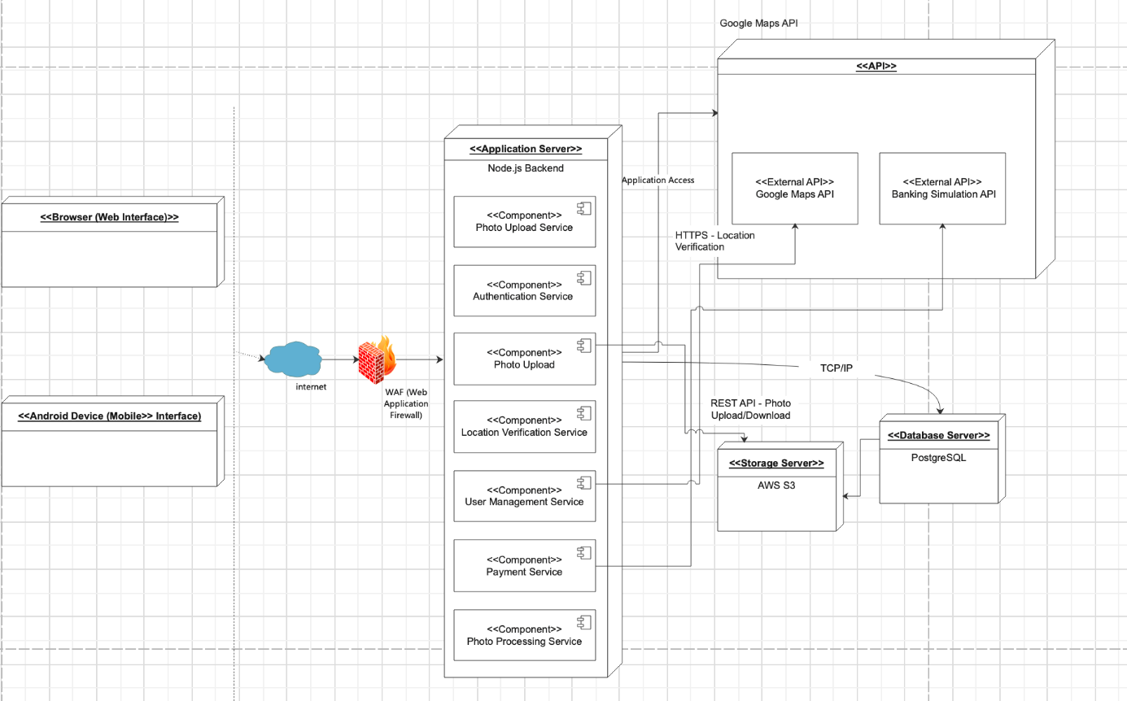

Figure 5 - UML Deployment Diagram

1. **Design Quality**

*NReq1.0:* 3 out of 5 new users, representing diverse personas, shall complete key user experience tasks such as updating profile information, uploading a photo, and reviewing a photo within 5 minutes, using no more than 10 GUI interactions.

*How Design Meets It:*

The frontend employs a Client-Server architecture, with an optimized user interface designed for responsiveness and simplicity. Features like tooltips, intuitive menus, and clear labels help guide new users through tasks with minimal interactions. The backend processes requests efficiently to ensure fast data retrieval and updates.

*Verification & Validation:*

Usability testing with new users will measure task completion times and interaction counts. Observational studies and feedback sessions will identify bottlenecks in the user experience.

*NReq1.1:* 3 out of 5 experienced users who have used the system for at least 8 hours, representing diverse personas, shall complete key user experience tasks such as updating profile information, uploading a photo, and reviewing a photo within 2 minutes, using no more than 10 GUI interactions.

*How Design Meets It:*

The design leverages responsive APIs and cached UI components for faster interactions, benefiting experienced users. Shortcuts and improved workflows (e.g., pre-filled fields) are implemented to help experienced users achieve tasks more quickly.

*Verification & Validation:*

Conducting time trials with experienced users will evaluate whether they can complete tasks within the required timeframe. Surveys will collect feedback on the speed and usability of the system for experienced users.[5]

*NReq2.0:* 3 out of 5 new users should report a satisfaction level of at least 3 out of 5 after completing key user tasks, such as updating profile information, uploading a photo, and reviewing a photo.

*How Design Meets It:*

The frontend component prioritizes usability with beginner-friendly designs, including error prevention and real-time feedback mechanisms for new users. The mobile app’s event-driven architecture ensures smooth interactions with GPS and camera features.

*Verification & Validation:*

Surveys conducted after tests will collect satisfaction ratings from new users. Observations during usability tests, and integration tests, will assess areas for improvement in the UI.

*NReq2.1*: 3 out of 5 experienced users who have used the system for at least 8 hours should report a satisfaction level of at least 4 out of 5 after completing key user tasks.

*How Design Meets It:*

Advanced users benefit from streamlined workflows, and faster response times in both the web and mobile apps. Consistent design elements across platforms reduces the learning curve for frequent users.

*Verification & Validation:*

Satisfaction surveys will be conducted with experienced users after usability tests. Feedback will be analyzed to identify enhancements to experienced user workflows.

*NReq3.0:* The system shall handle 200 simultaneous users.

*How Design Meets It:*

The backend is designed with a client-server architecture that uses efficient database connections and optimized API endpoints to handle simultaneous requests. The banking module, designed as a microservice, ensures isolated and efficient handling of financial transactions, relieving the backend of executing those tasks and allowing it to focus on other tasks.

*Verification & Validation:*  
Load testing tools like Apache JMeter[6] will simulate 200 concurrent users to measure system performance. Logs will be analyzed for bottlenecks.

*NReq4.0:* Web user interface documents should be rendered within 2 seconds under normal workload conditions 95% of the time.

*How Design Meets It:*

The frontend employs optimized asset delivery, including lazy loading[7] and minimized JavaScript. Backend APIs use efficient database queries to provide fast responses to client requests.

*Verification & Validation:*

In addition to Integration testing to see how the frontend and backend work when they are integrated together, Performance testing with tools like Lighthouse or Google PageSpeed Insights[8] will monitor page load times under various workloads.

*NReq5.0:* The Web API shall respond to text-based requests within 700ms under normal workload conditions, 95% of the time.

*How Design Meets It:*

Asynchronous API design and optimized database queries reduce response times. The backend ensures minimal latency by leveraging caching and indexing strategies.

*Verification & Validation:*

API testing tools like Postman or Apache JMeter will measure average response times. Results will be validated against the 700ms threshold.

*NReq6.0:* System shall experience no more than 2 level-one faults per month.

*How Design Meets It:*

Fault-tolerant mechanisms are implemented through microservices, containerized environments, and automated recovery systems. Critical services like the banking system operate independently to limit cascading failures.

*Verification & Validation:*

Fault injection testing and monthly log analysis will verify the number of level-one faults.[9] Incident reports will confirm compliance.

*NReq6.1:* System shall experience no more than 5 level-two faults per month.

*How Design Meets It:*

Error handling and detailed logging ensure quick identification and resolution of non-critical faults. Utilization of modular design in event-driven and microservice architectures localizes faults.

*Verification & Validation:*

Regular error log reviews and incident tracking will confirm the monthly fault count remains below five.

*NReq7.0:* The system architecture shall replace failed system modules with healthy ones automatically.

*How Design Meets It:*

Microservices and container orchestration tools, like Docker which is used in the project, ensure failed containers or services are replaced automatically, helping the project meet reliability requirements.

*Verification & Validation:*

Chaos testing, a form of testing where elements in a given application are intentionally broken, will be conducted. Tools like Gremlin will simulate failures to validate automatic replacement functionality.

*NReq8.0:* Data transactions using tokens should be secured with the HS256 algorithm for integrity.

*How Design Meets It:*

API endpoints use JSON Web Tokens (JWT) signed with HS256 for secure authentication and transaction integrity.

*Verification & Validation:*

Static code analysis with tools like SonarQube will verify token implementation. Penetration testing will be used to ensure token security.[10]

*NReq9.0:* Server service ports shall not be exposed to the public.

*How Design Meets It:*

Firewalls and virtual private networks (VPNs) restrict access to service ports, ensuring they are not exposed to unauthorized users.[11]

*Verification & Validation:*

Network scans with Nmap, a free security scanner, will confirm no exposed ports.

*NReq10.0:* Web services should be secured with TLS and RSA encryption, utilizing SHA-256 to protect against attacks such as man-in-the-middle.

*How Design Meets It:*  
TLS certificates and RSA-based key exchanges secure communication. All data exchanges are hashed using SHA-256.

*Verification & Validation:*

We will not verify and validate this non-functional requirement.

*NReq11.0:* System shall use a salting technique as SHA-256 to keep user passwords secure.

*How Design Meets It:*

User passwords will be hashed and salted using SHA-256, ensuring strong encryption for stored credentials.

*Verification & Validation:*

Code reviews will be conducted to verify the system implements the codes necessary for this requirement. Additionally, Penetration testing will be done to confirm password hashing compliance.[12]

*NReq12.0:* The average time for a maintenance engineer to repair a severity-2 defect shall be no greater than 8 person-hours.

*How Design Meets It:*

The system’s modular design, using microservices for the banking system and event-driven architecture for the Android app, ensures that defects are isolated to specific components. Detailed logging and monitoring tools will be implemented to provide precise diagnostic information, enabling quick identification and resolution of issues.

Ve*rification & Validation:*

Incident reports will track the time required to fix severity-2 defects. The engineer in question can also manually track the time required using a timer. Maintenance simulations will be conducted to validate whether repairs can be completed within 8 person-hours.

*NReq13.0:* Web software modules shall be designed to be run on Windows, MacOS, and Linux operating systems, ensuring a high degree of flexibility when porting to alternative environments.

*How Design Meets It:*

Containerization using Docker ensures that the web application can run on various operating systems with minimal changes. The use of platform-independent technologies like TypeScript for the frontend and Node.js for the backend further enhances portability.

*Verification & Validation:*

The system will be deployed and tested on Windows, MacOS, and Linux environments to confirm compatibility and functionality.

*NReq14.0:* The application shall be developed in a proven portable programming language to enhance compatibility across various operating systems.

*How Design Meets It:*

TypeScript is used for the web frontend, and Node.js is used for the backend. Both are well-established, portable programming languages that allow seamless deployment across different operating systems.

*Verification & Validation:*

Cross-platform testing will ensure consistent performance of the application across different operating systems.

*NReq15.0:* Web applications shall be deployed using containerization so that it achieves consistent performance across various environments, enhances scalability by allowing for rapid deployment and scaling of application instances, isolates components to prevent failures from affecting the entire system, and simplifies maintenance and management through integration with container orchestration tools.

*How Design Meets It:*

The entire system is containerized using Docker, with orchestration managed via Kubernetes.[13] This ensures isolated environments for different components (e.g., frontend, backend, banking microservice) and consistent performance across deployments.

*Verification & Validation:*  
Deployment testing will confirm seamless operation in containerized environments. Kubernetes’ orchestration capabilities will be verified using scalability testing. *NReq16.0:* Web applications shall be implemented using TypeScript.

*How Design Meets It:*

The web frontend is developed entirely in TypeScript, ensuring strong typing and error-checking at compile time, which reduces runtime errors and improves maintainability.

*Verification & Validation:*

Code reviews will confirm the exclusive use of TypeScript in the frontend. SonarQube will be used to ensure the project’s adherence to TypeScript language standards.

*NReq17.0:* The map shall be displayed using the Google Maps API.

*How Design Meets It:*

The Google Maps API is integrated into the web and mobile applications for location-based features, such as geotagging photos and displaying user-uploaded content on a map.

*Verification & Validation:*

Integration testing will verify the integration and responsiveness of the Google Maps API in all supported browsers and devices.

*NReq18.0:* System shall warn users of non-critical user errors, such as inputting text in numeric fields.

*How Design Meets It:*

Frontend will implement validation mechanisms to detect user errors in real time. Error messaging will be used to notify and guide the users.

*Verification & Validation:*

During Integration testing incorrect inputs will be submitted to simulate input errors to confirm that appropriate warnings are displayed and users are guided toward resolution.

*NReq19.0:* System shall log non-critical external system errors, such as failure to display a map.

*How Design Meets It:*

The system includes logging mechanisms to capture non-critical errors from external systems, such as Google Maps API failures. These logs help developers monitor and debug issues without impacting user experience.

*Verification & Validation:*

Logs will be reviewed during tests where the external system is intentionally disconnected or unavailable to confirm accurate logging of non-critical errors.

*NReq20.0:* System shall log critical external system errors, such as monetary transaction failures.

*How Design Meets It:*

Critical external system errors, such as failed operations in the banking system, are logged with high-priority alerts sent to the development team. These logs include detailed diagnostic information for fast resolution.

*Verification & Validation:*

Fault injection testing will be utilized to simulate transaction failures, and the logs will be examined to ensure critical errors are recorded accurately and with sufficient detail.

*NReq21.0:* System shall log errors and aim to avoid crashing the entire system.

*How Design Meets It:*

Modular design ensures that errors in one component (e.g., the banking system or photo upload process) do not propagate and crash the entire system. Logs are generated for all errors with varying priority levels based on severity.

*Verification & Validation:*

In addition to Integration testing, Stress testing will be utilized to simulate multiple simultaneous errors to confirm that the system logs them effectively without crashing. Error logs will be reviewed to ensure completeness.

*NReq22.0:* System shall communicate with the Bank API to perform monetary transactions.

*How Design Meets It:*

The banking system, designed as a microservice, uses REST APIs to handle monetary transactions. Secure communication protocols ensure data integrity during these transactions.

*Verification & Validation:*

Integration tests will validate the communication between the system and the banking API. Security testing will be utilized to verify encryption and prevent unauthorized access.

# Low Level Design

U14 – Purchase Now

The “Purchase Now” Use Case is about letting users instantly buy the photos they want. This action is not applicable for all photos as the main objectivity of the app is about auctioning them. However, since the photos will first be filtered via a voting system, and then through the auction itself, it is not guaranteed that all photos will be bought in the end. Because of this, we decided to include a “Purchase Now” option for such photos, so that if they were just unlucky at the voting stage or auctioning phase, those photos still can be bought at a later time without actually waiting for an auction to take place. The pseudo code for this Use Case is as the following:  
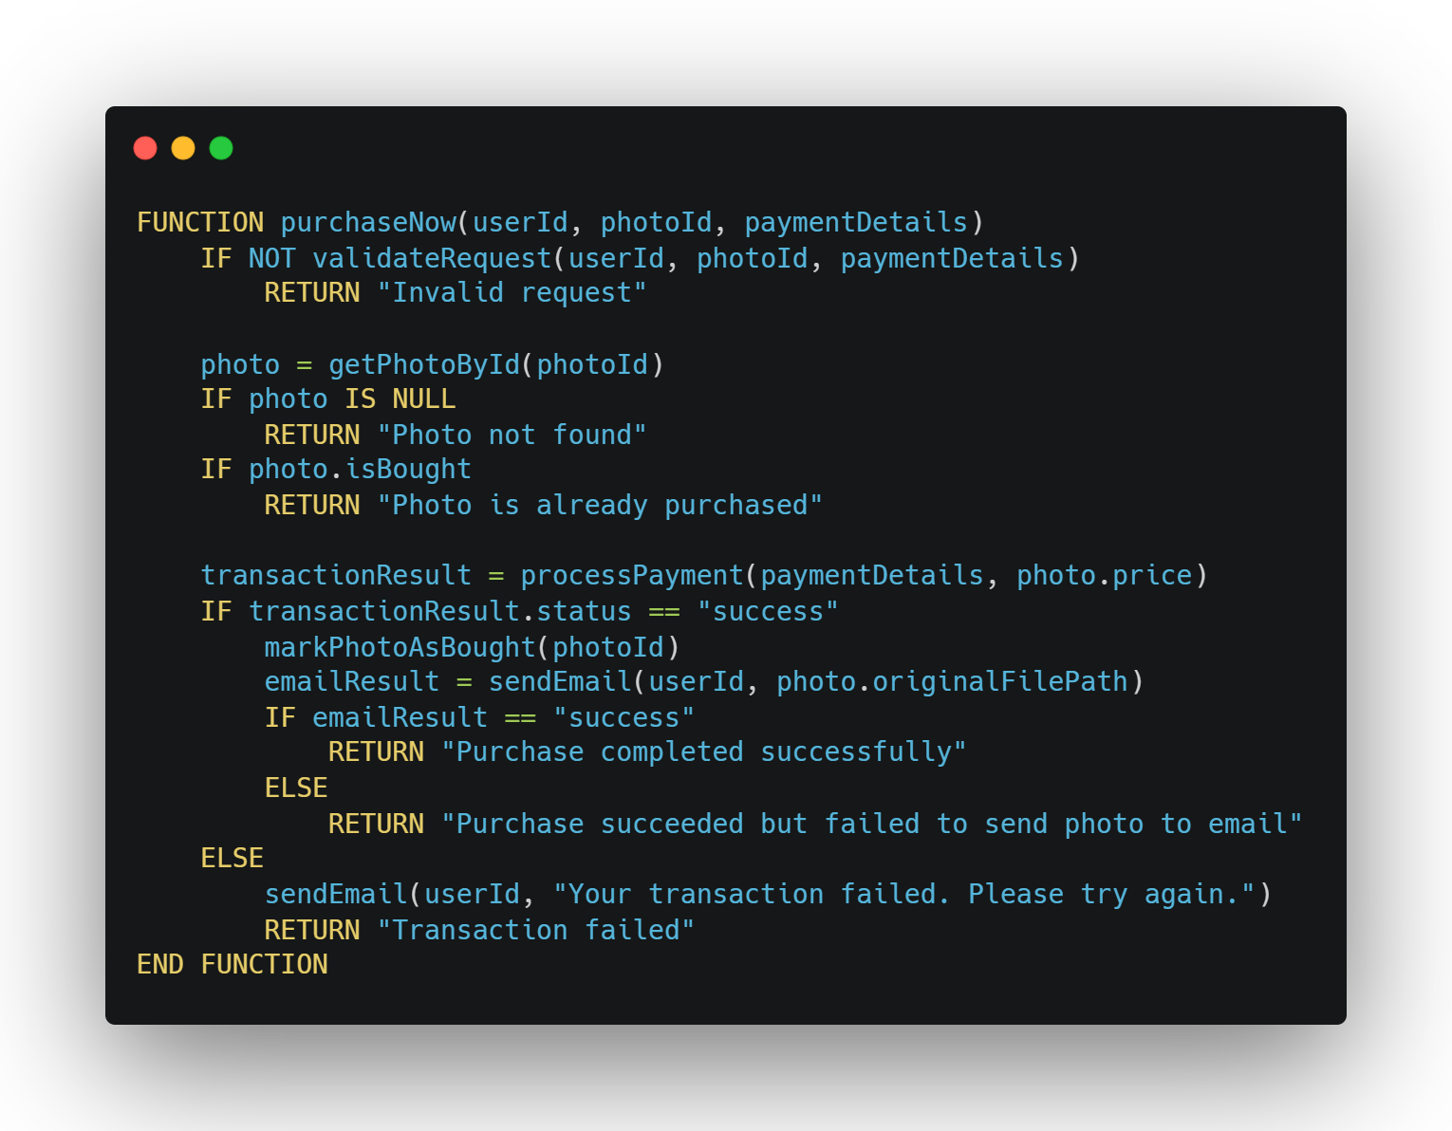

Figure 6 - U14 Pseudo Code

And the following are the UML Activity, Sequence and Class Diagrams of this Use Case.

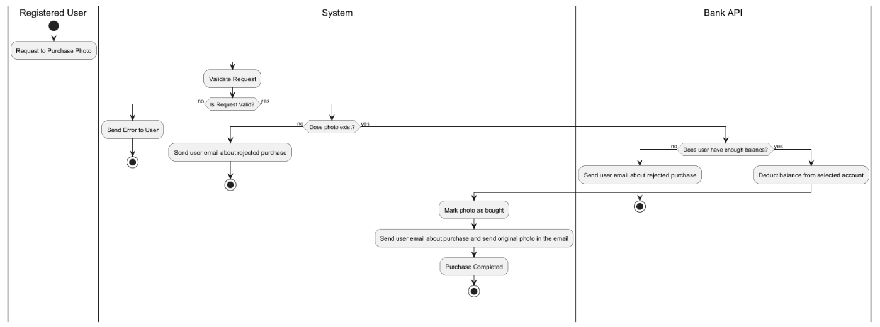

Figure 7 - U14 UML Activity Diagram

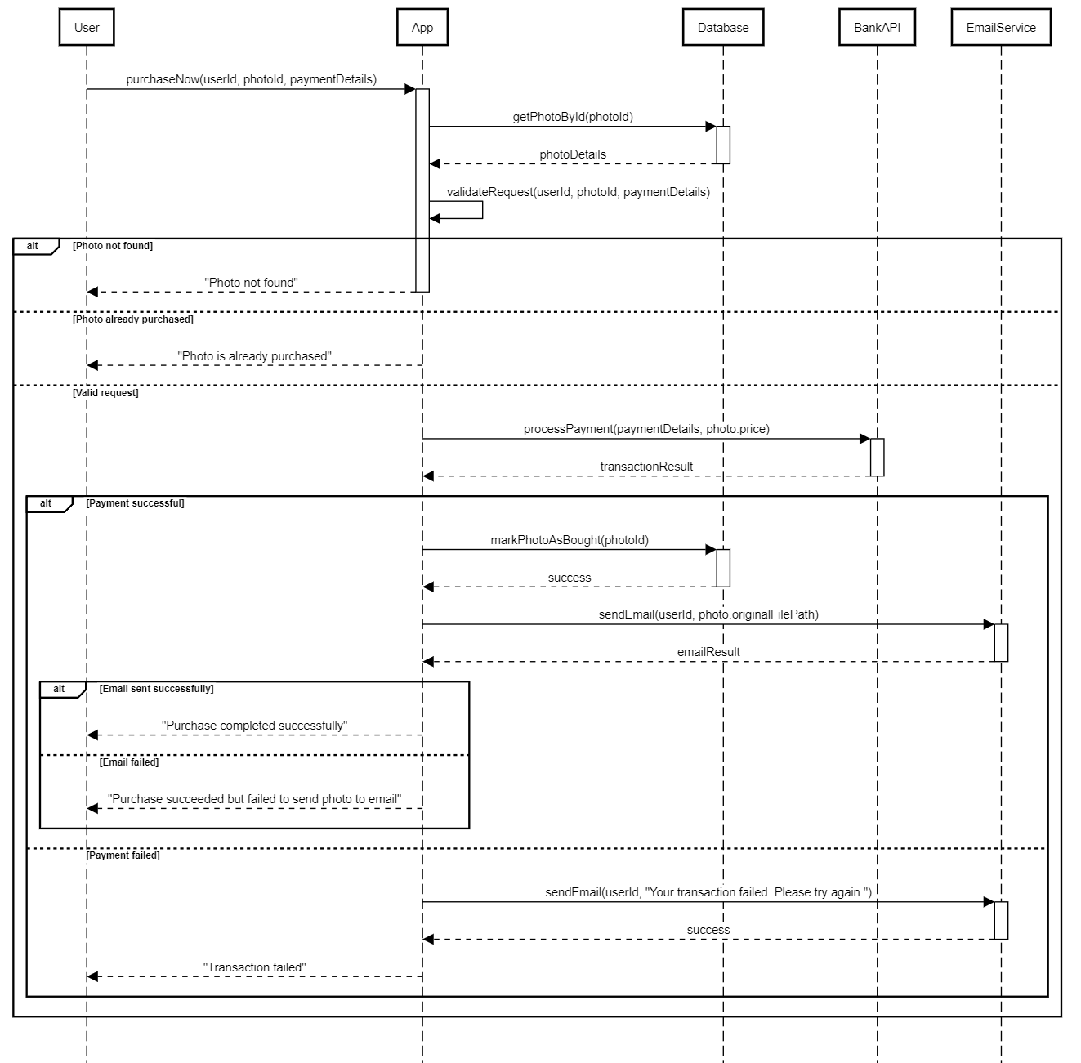

Figure 8 - U14 UML Sequence Diagram

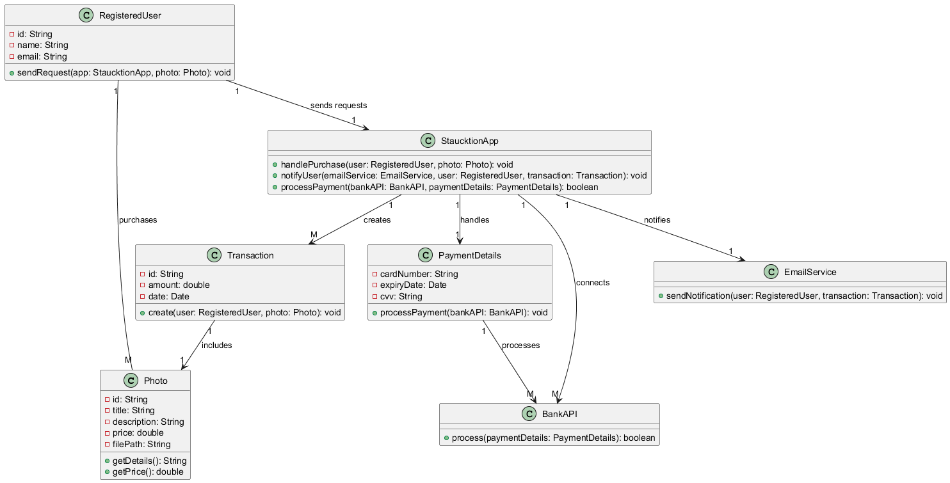

Figure 9 - U14 UML Class Diagram

U17 – Manage Watermarked Photo

The “Manage Watermarked Photo” use case ensures that watermarked photos are effectively handled within the system to protect intellectual property and ensure proper usage of visual content. This use case includes other functionalities, such as "Take Photo" and "Upload Photo," which were implemented and documented individually in the First Increment. Currently, there are no specific implementations or additional operations unique to this use case within the current code of the First Increment, and therefore, there is nothing to document beyond what has already been addressed.

This use case's primary purpose is to coordinate the interaction between existing processes, ensuring that watermarked photos are created, uploaded, and managed consistently. It plays an integral role in maintaining the security and integrity of image-related workflows, while avoiding redundant documentation for operations already covered under related use cases.

As no unique processes or functionalities are tied solely to this use case, diagrams have not been created. The existing components are straightforward and modular, with their individual complexities captured in the respective documentation for "Take Photo" and "Upload Photo." The absence of additional diagrams does not diminish the importance of this overarching use case but reflects a focus on reusing documented features and avoiding unnecessary duplication.[14]

U18 – Take Photo

The "Take Photo" use case allows a registered user to capture a photograph within the application while ensuring the necessary permissions and prerequisites are met. The user must first log in to the system and access the "Take Photograph" section. The application then verifies if the camera, storage, and location permissions are granted. If permissions are denied, the user is prompted to grant them. The system also ensures that GPS is enabled to capture the location metadata. Once all checks are passed, the camera interface is opened, and the user can capture the photo. After the photo is taken, the system validates that GPS is still active to ensure accurate metadata embedding. Finally, the application notifies the user of the successful capture and stores the photo along with its timestamp and GPS coordinates. This process ensures a seamless and permission-compliant experience for capturing and storing photographs with location details. The pseudo code for this Use Case is as the following: [15]

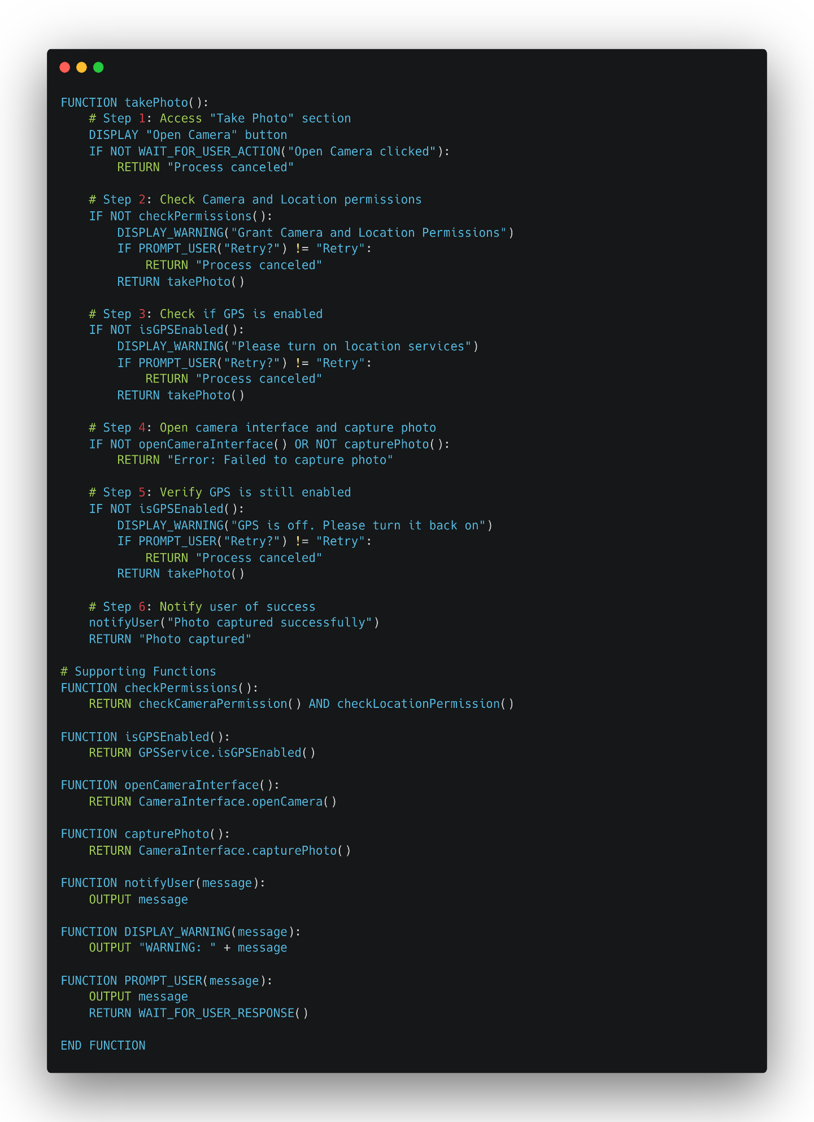

Figure 10 - U18 Pseudo Code

And the following are the UML Activity, Sequence and Class Diagrams of this Use Case.

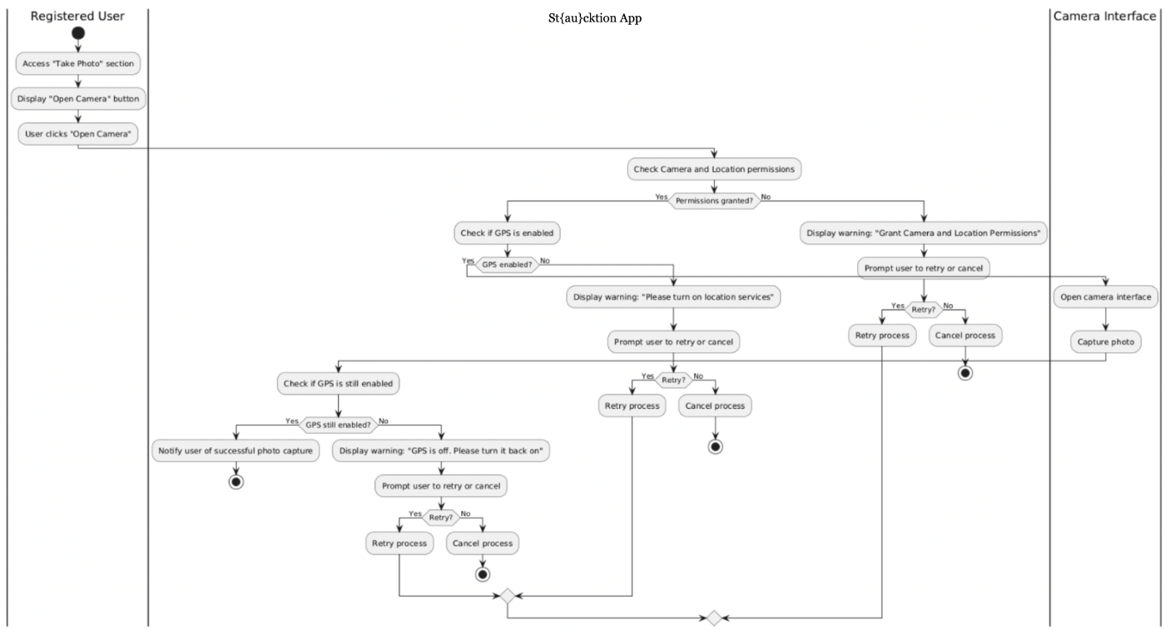

Figure 11 - U18 UML Activity Diagram

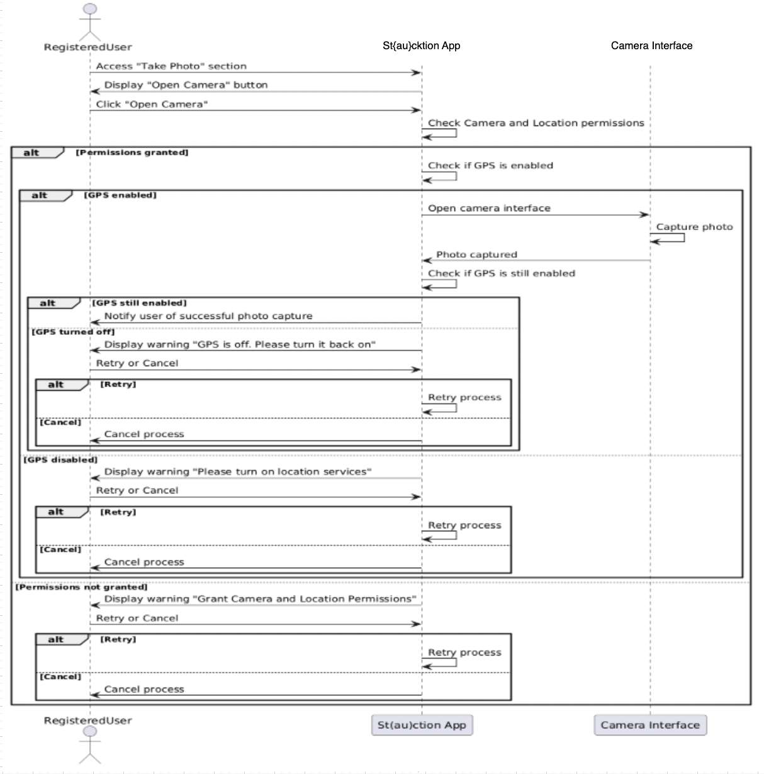

Figure 12 - U18 UML Sequence Diagram

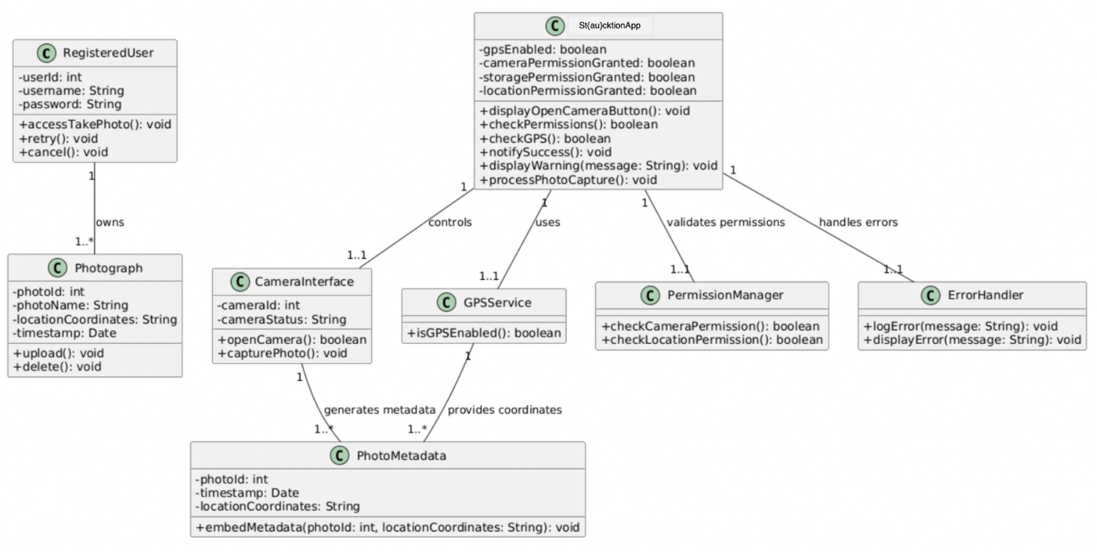

Figure 13 - U18 UML Class Diagram

U20 - Upload Photo

The "Upload Photo" use case enables a registered user to upload a photo to the St{au}cktion app for auctioning purposes. The system first checks whether GPS is enabled on the user's device. If GPS is active, the app retrieves the photo path and uploads the image to the server. Upon a successful upload, the user is notified with a success message; otherwise, a failure message is displayed. If GPS is disabled, the app prompts the user to enable location services to proceed. This ensures compliance with geolocation-based requirements for uploaded photos, enhancing app functionality and user experience.[16] The pseudo code for this Use Case is as the following:

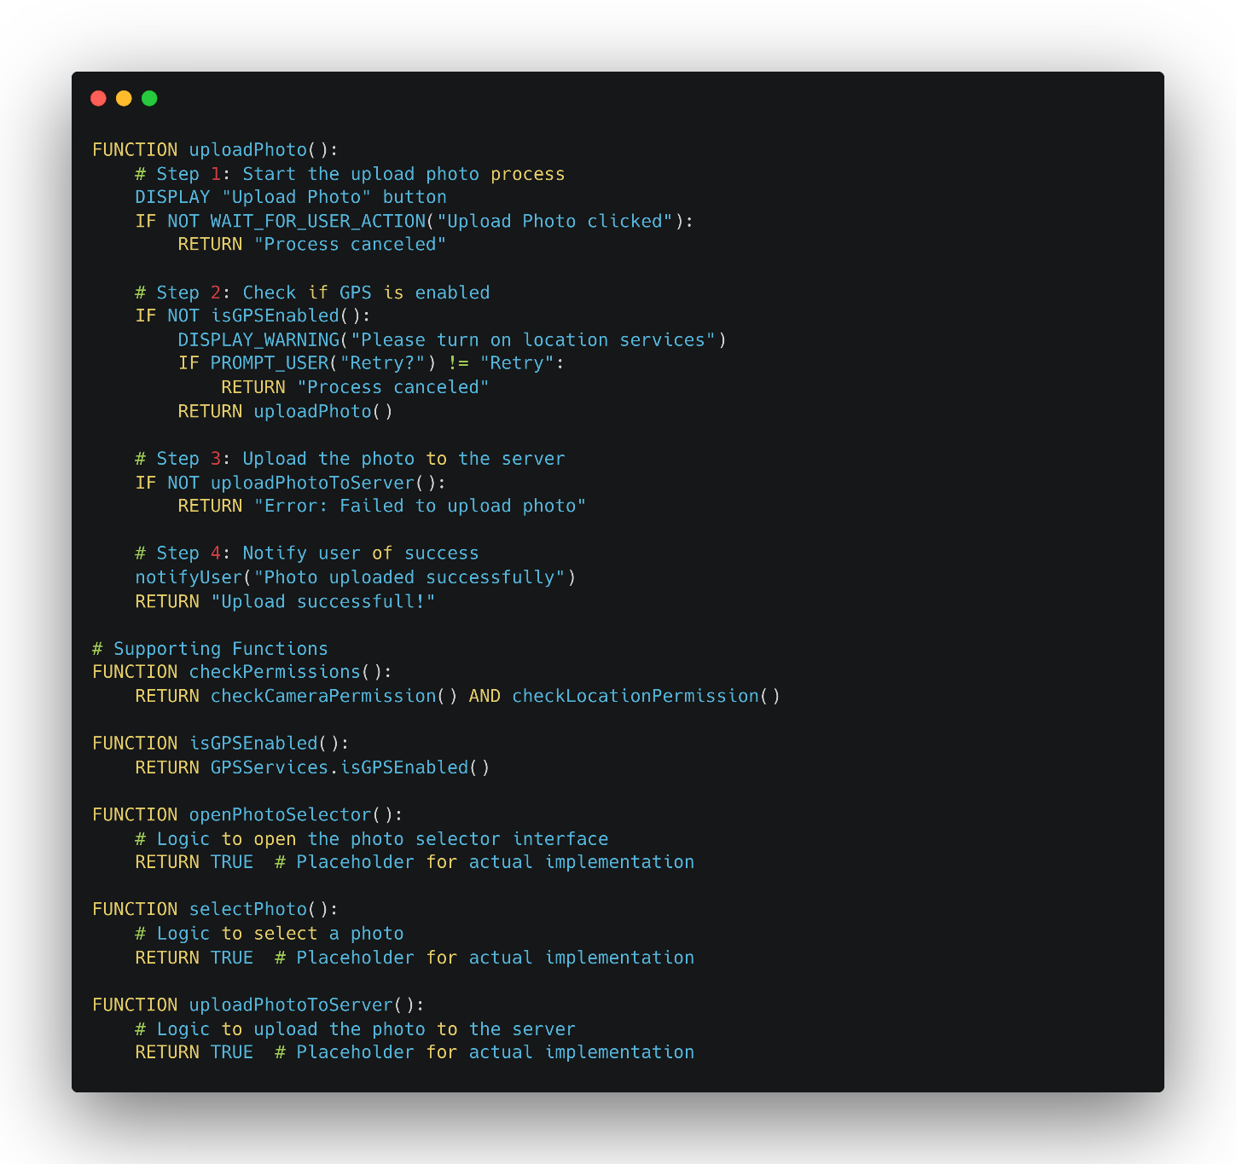

Figure 14 - U20 Pseudo Code

And the following are the UML Activity, Sequence and Class Diagrams of this Use Case.

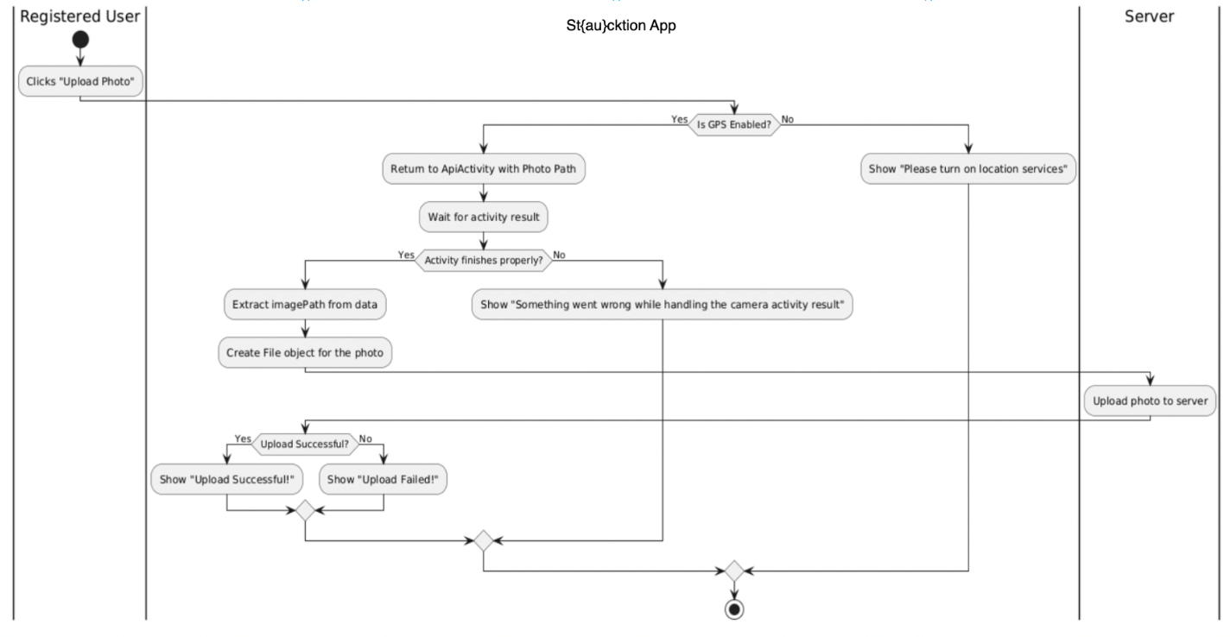

Figure 15 - U20 UML Activity Diagram

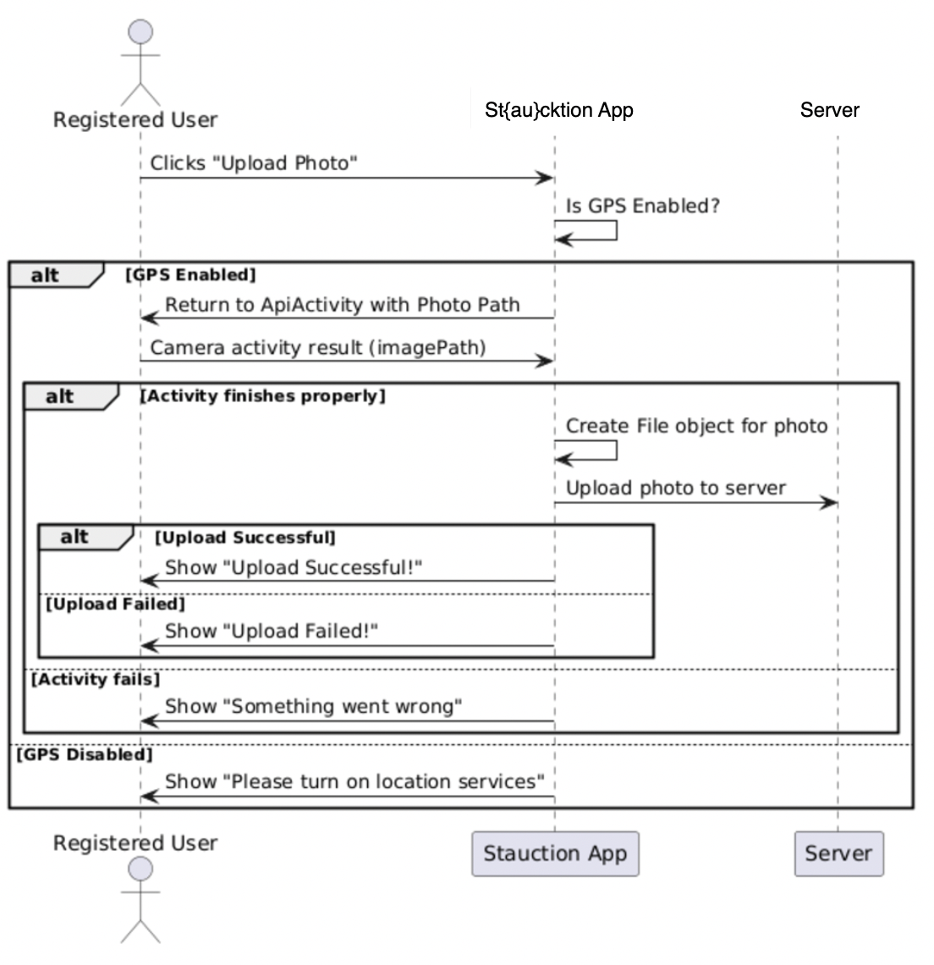

Figure 16 - U20 UML Sequence Diagram

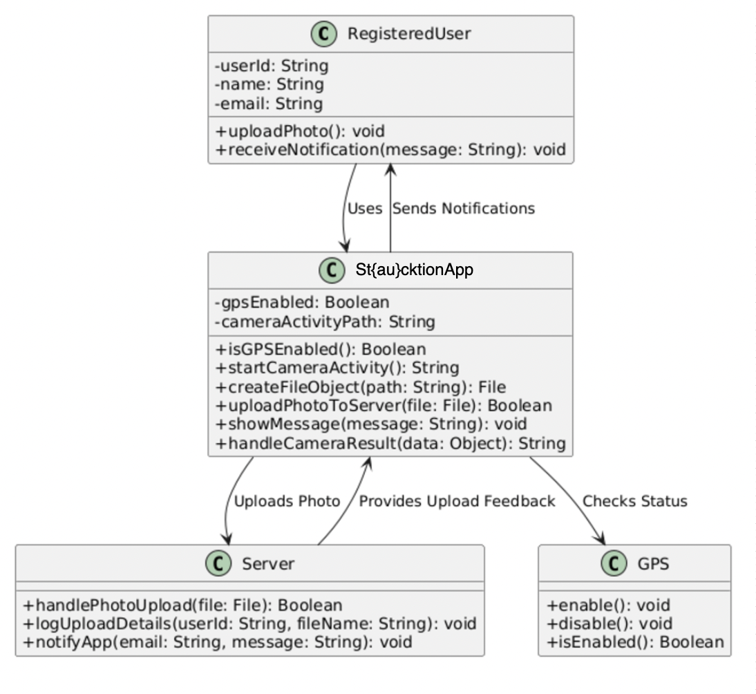

Figure 17 - U20 UML Class Diagram

BU1 – Check Balance

The “Check Balance” use case provides an API endpoint to retrieve the current balance and related details of a specified bank account. When a request is made, the system queries the account and returns the requested information, such as the balance and other relevant data. This functionality supports error handling for scenarios like invalid account identifiers or unauthorized access attempts. The process ensures that only authorized users can access account details and that any errors are appropriately communicated through status codes and messages. The documentation for this use case includes details about the API endpoint, including the request and response structure, required parameters, and example usage. It also specifies potential error responses and their meanings to aid in development and troubleshooting. The “Check Balance” endpoint is a core feature of the Banking Simulation API, providing straightforward access to account information necessary for other financial operations.[17] The pseudo code for this Use Case is as the following:

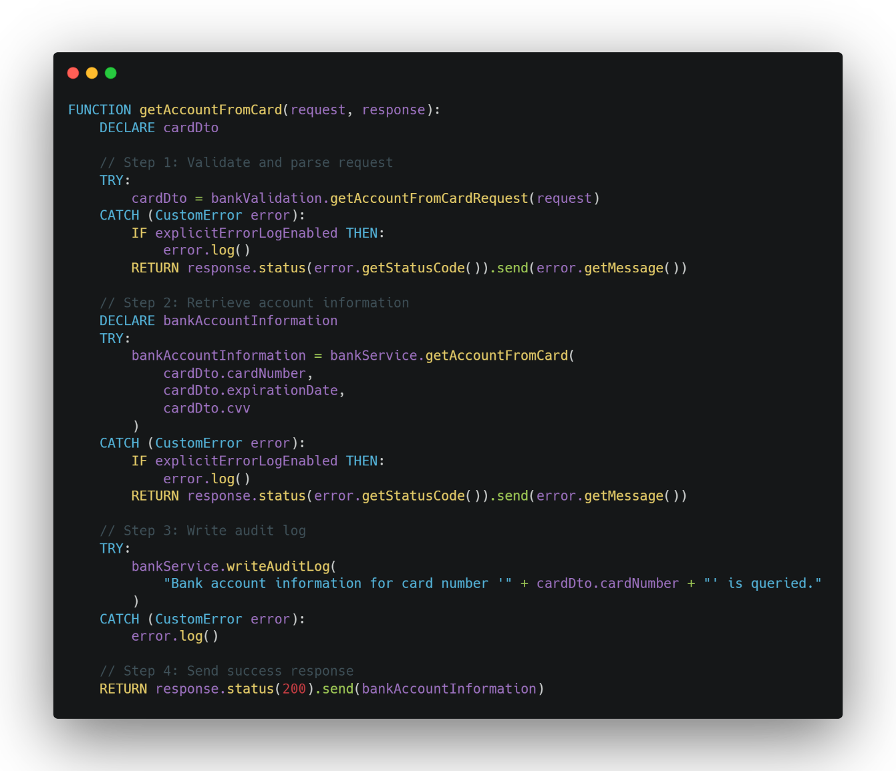

Figure 18 - BU1 Pseudo Code

And the following are the UML Activity, Sequence and Class Diagrams of this Use Case.

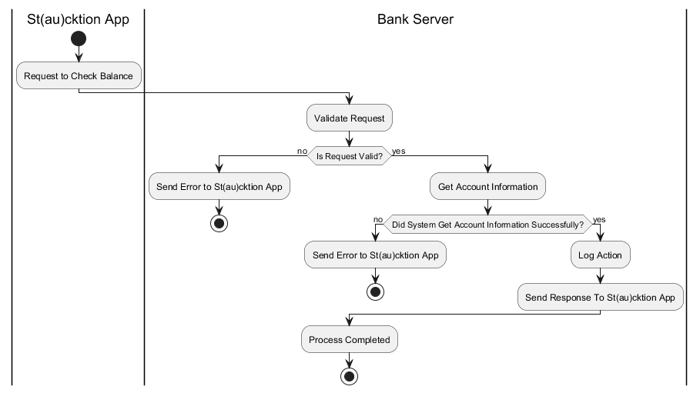

Figure 19 - BU1 UML Activity Diagram

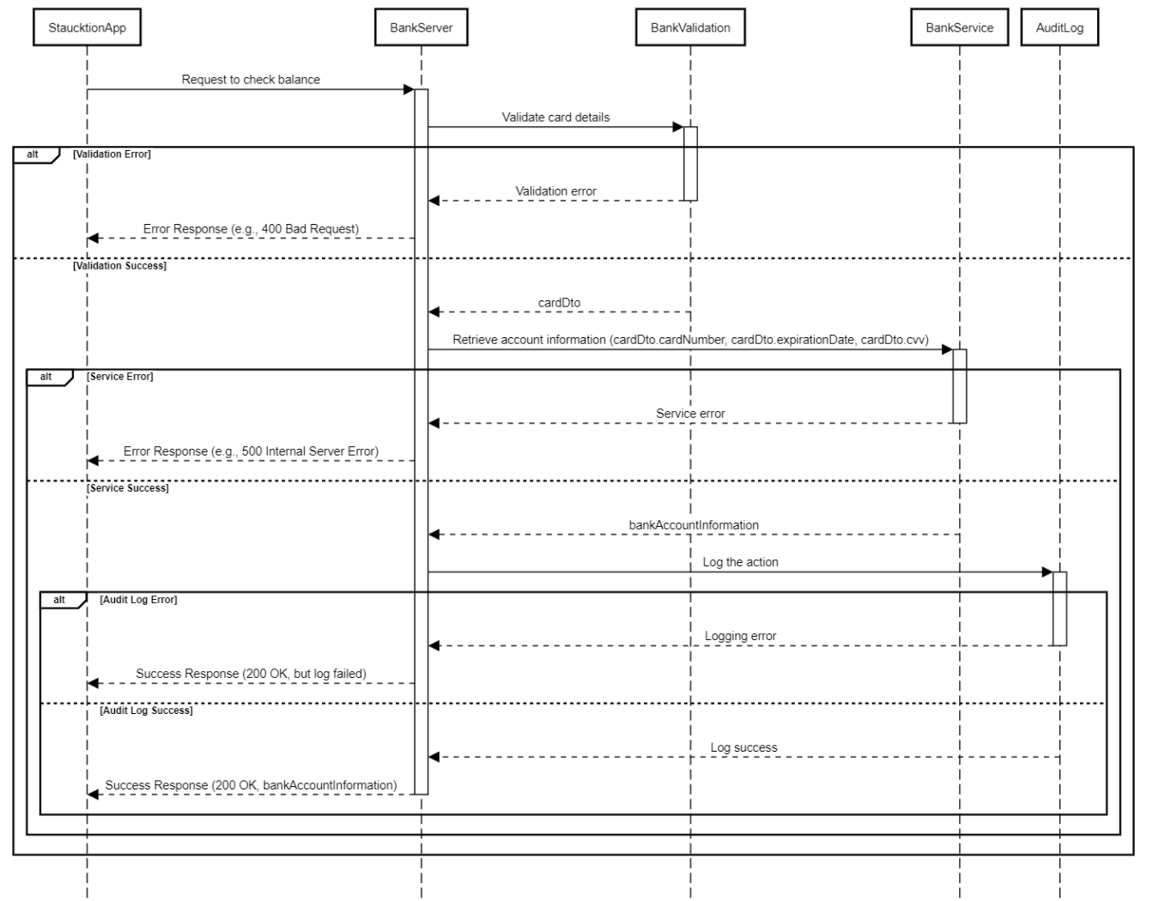

Figure 20 - BU1 UML Sequence Diagram

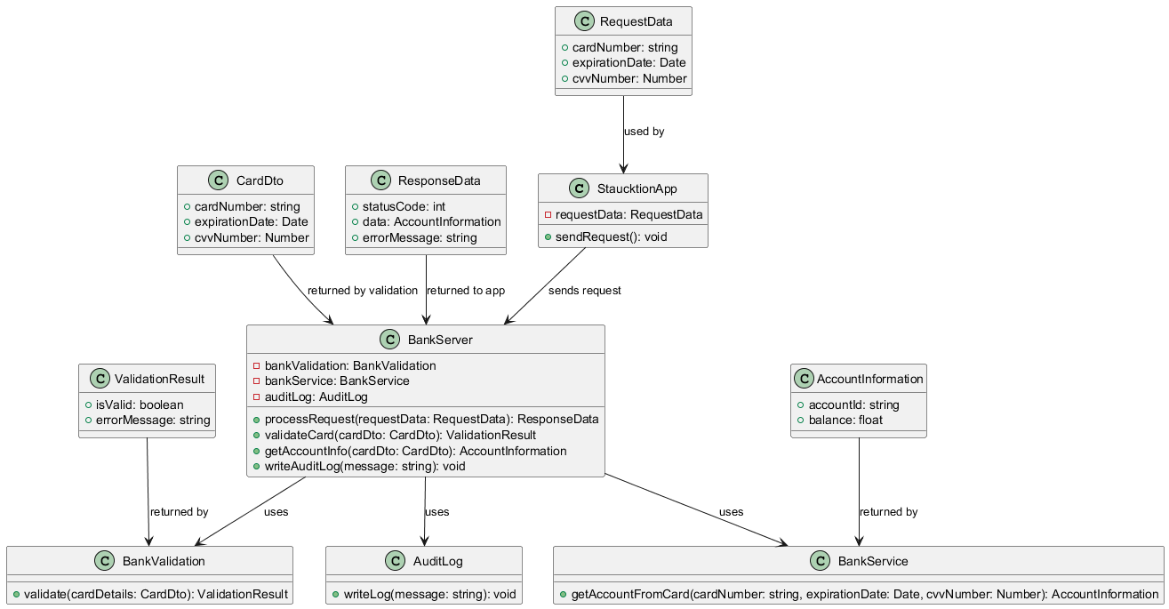

Figure 21 - BU1 UML Class Diagram

BU2 – Make Transaction

The “Make Transaction” process allows transferring funds between two specified accounts in the Banking Simulation API. When a request is made to the endpoint, the system validates the account details and transaction parameters, processes the transfer, and updates the account balances. The endpoint includes error handling for scenarios such as insufficient funds, invalid account identifiers, or unauthorized access attempts. It ensures that account balances are updated accurately and consistently. Documentation includes details about the API endpoint, such as request and response formats, required parameters, example payloads, and error codes. This helps developers integrate the functionality and troubleshoot effectively. The “Make Transaction” functionality is a key part of the Banking Simulation API, enabling users to perform balance transfers and ensuring the system operates reliably.[18] The pseudo code for this Use Case is as the following:

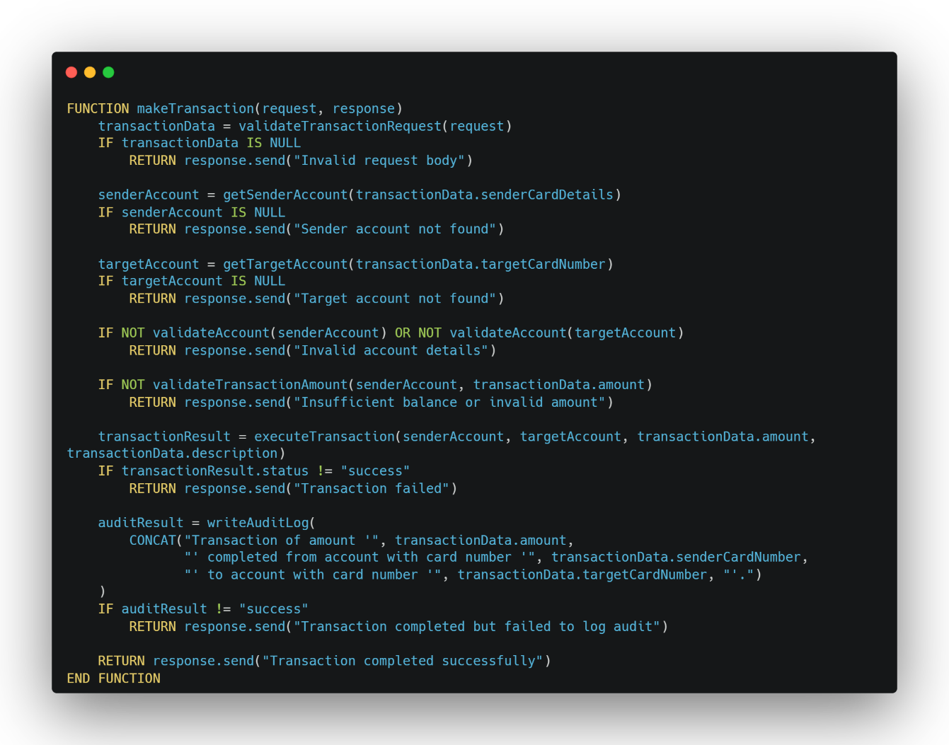

Figure 22 - BU2 Pseudo Code

And the following are the UML Activity, Sequence and Class Diagrams of this Use Case.

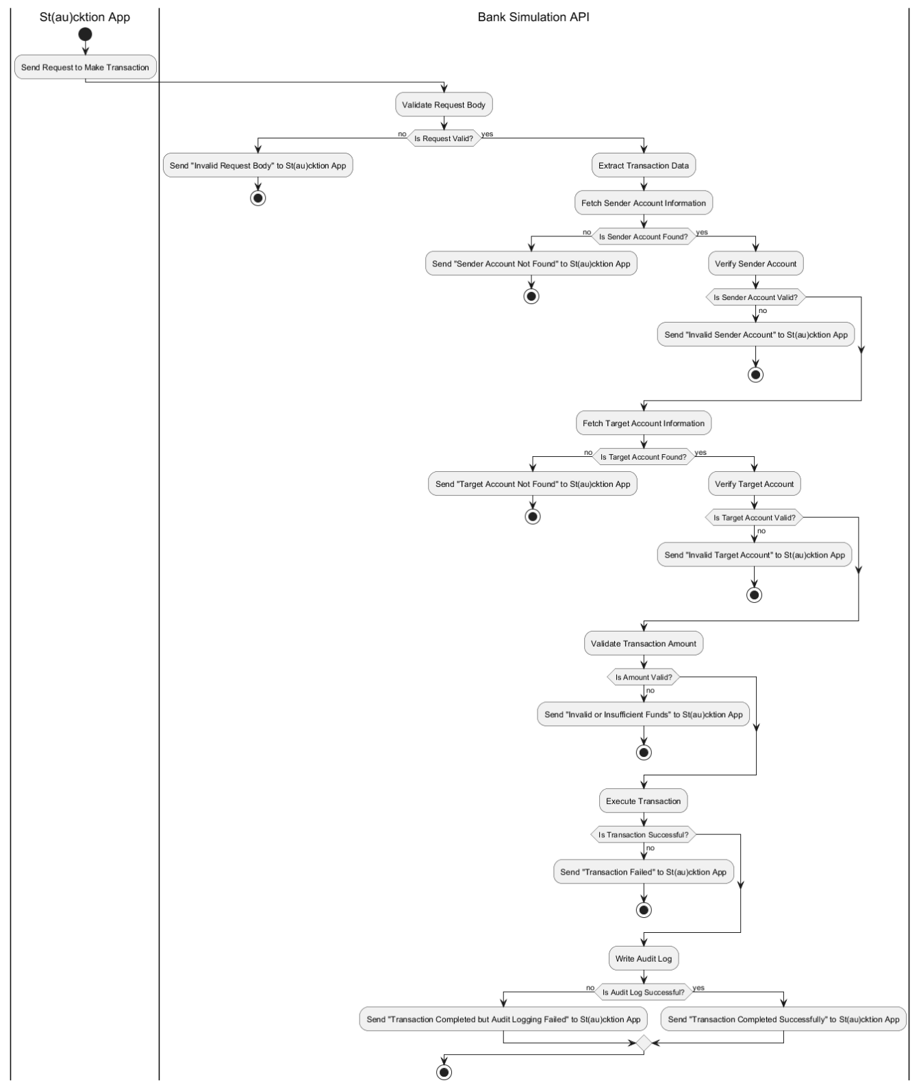

Figure 23 - BU2 UML Activity Diagram

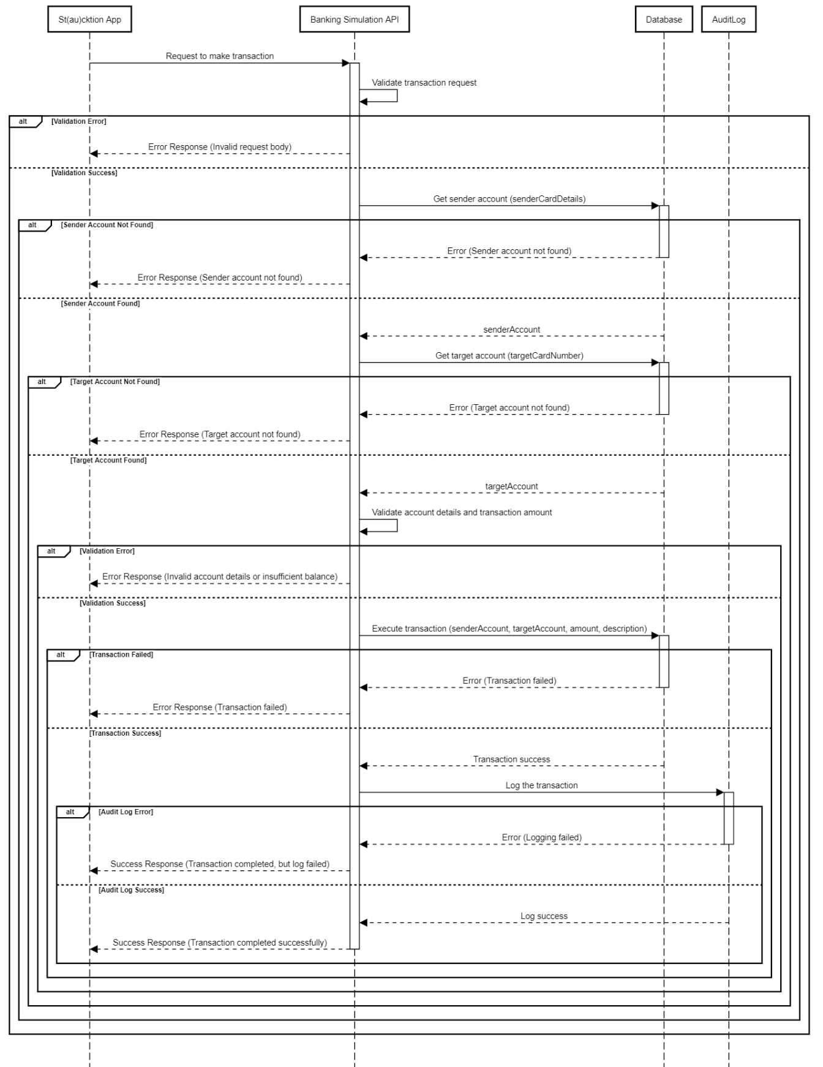

Figure 24 - BU2 UML Sequence Diagram

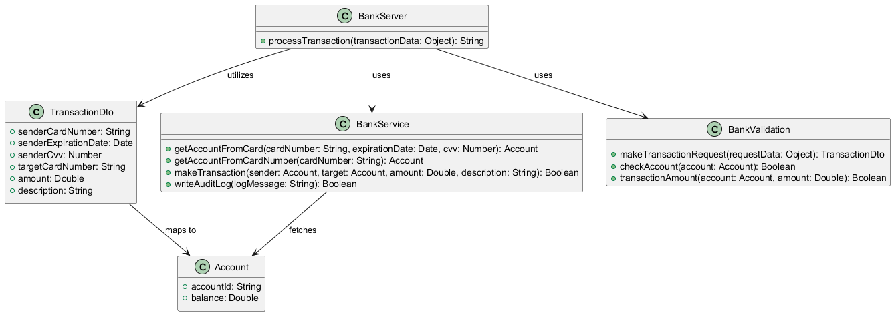

Figure 25 - BU2 UML Class Diagram

BU3 – Log Actions

The “Log Action” use case ensures that all key transactions and actions within the system, such as bids, fund provisions, payments, and refunds, are recorded for auditing and troubleshooting purposes. Every user activity, including successful bids, failed transactions, and refunds, is systematically logged to provide a clear history of events. These logs help maintain transparency, improve security, and facilitate the resolution of disputes or errors by offering detailed insights into system operations. Additionally, the logging system captures and highlights successful actions, such as completed transactions, confirmed payments, and fulfilled refunds, ensuring that positive outcomes are also documented for accountability and tracking purposes. The diagrams for Log Action and related processes were not created because these processes are straightforward backend operations that do not involve complex user interactions or decision flows, making diagrams less critical for their understanding. However, it is worth noting that logging is an integral part of the platform's backend processes and plays a crucial role in ensuring accountability and reliability. The absence of diagrams here does not undermine the importance of these functionalities but reflects a focus on pseudocode and descriptive explanations instead.[19]

BU4 – Manage Provision

The “Manage Provision” process ensures secure and efficient handling of funds during an auction. When a user places a bid, the system deducts the bid amount from their bank balance and temporarily holds it in a provisioned state. This ensures that the user has sufficient funds to honor their bid while preventing misuse or withdrawal during the auction. If the user wins the auction, the provisioned funds are finalized as payment for the item. However, if the user does not win, the provisioned amount is refunded back to their bank balance, ensuring transparency and fairness. This process not only safeguards the auction platform but also provides users with confidence that their funds are handled responsibly. The manage provision functionality acts as a critical component in maintaining trust and reliability in the auction system.[20] The pseudo code for this Use Case is as the following:

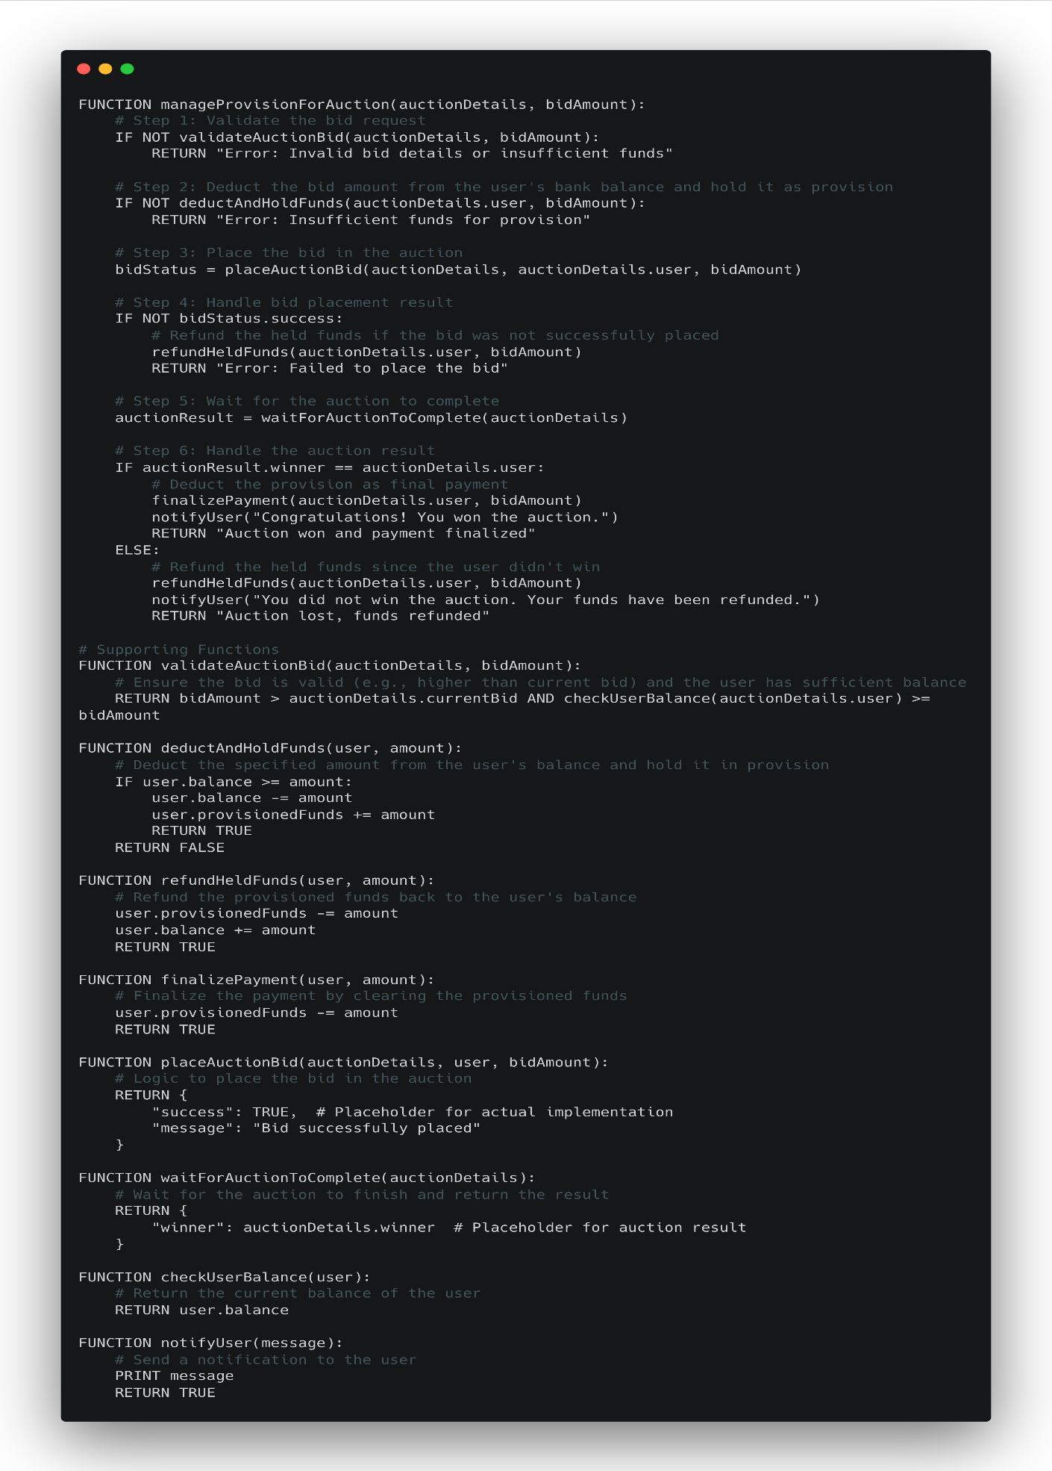

Figure 26 - BU4 Pseudo Code

And the following are the UML Activity, Sequence and Class Diagrams of this Use Case.

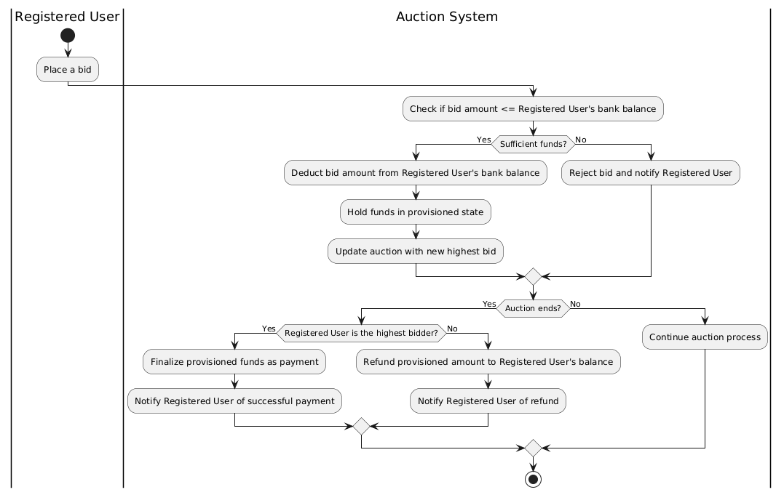

Figure 27 - BU4 UML Activity Diagram

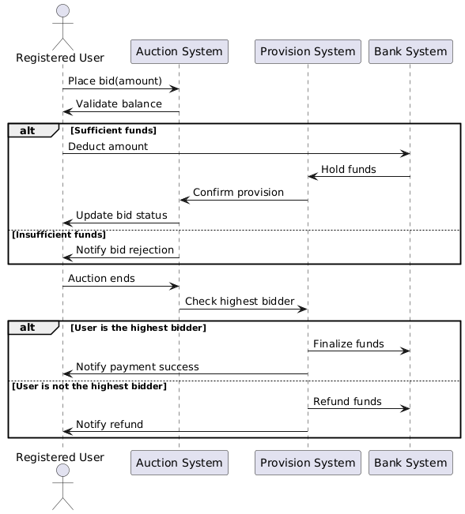

Figure 28 - BU4 UML Sequence Diagram

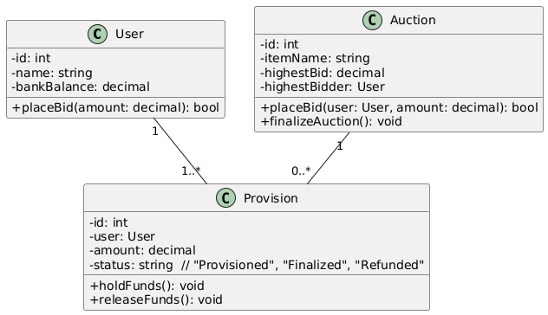

Figure 29 - BU4 UML Class Diagram

# Discussions

## Limitations and Constraints

Since the preparation time frame of SDD document conflicted with the Final exams’ time frame, we had issues with dedicating enough time for preparing this document. Also, there were not enough sources available online for specifications of UML Block Diagram and UML Deployment Diagrams. Additionally, we had to try to “limit” ourselves from saying the words “Aynen” and “Sıkıntı”.

## Health and Safety Issues

Most of our team members didn’t have enough time to prepare the document while studying for their exams, therefore their mental health is seriously affected by this.

## Legal Issues

We did not experience any legal issues while preparing the SDD.

## Economic Issues and Constraints

Some of our team members had to pay extra money to buy LucidCharts and ChatGPT Pro memberships while preparing the required diagrams and texts for this document.

## Sustainability

We held our meetings on Zoom to avoid in-person gatherings, which would require everyone to use transportation that contributes excess carbon emissions to the environment. We also used digital tools like Notion and GitHub to minimize paper usage by keeping all documents and collaboration online.

## Ethical Issues

We did not experience any ethical issues while preparing this document.

## Multidisciplinary Collaboration

We did not collaborate with anyone from other departments, so this section is not applicable for us.

# References

|  |  |
| --- | --- |
| [1] | Ergin, Erkan, Köklü, Özer and Yeşilyurt, "Second Version of Software Project Management Plan of Team 10," 2024. |

1. GenAI Tool: ChatGPT 4

   Prompt: Please summarize this document into a one-page length text that outlines the most important parts of the decisions documented inside this document to provide a quick glance to the document

   Rationale: To create a summary without missing important details
2. GenAI Tool: ChatGPT 4

   Prompt: Please provide the scope of the contents of this document to have a kind of “more detailed” version of the Table of Contents of the whole document

   Rationale: To create the scope of the document
3. GenAI tool: ChatGPT 4o

   Prompt: Write an explanation for the given image.

   Rationale: Explaining the image properly
4. GenAI tool: ChatGPT 4o

   Prompt: Write an explanation for the given image.

   Rationale: Explaining the image properly
5. GenAI Tool: ChatGPT 4

   Prompt: How to do verification and validation for this non-functional requirement?

   Rationale: To get an idea 
6. GenAI Tool: ChatGPT 4

   Prompt: How to do verification and validation for this non-functional requirement?

   Rationale: To get an idea
7. GenAI Tool: ChatGPT 4

   Prompt: How to design the app so it meets the requirement? Below is an example of the requirements: [requirements here]

   Rationale: To get an idea 
8. GenAI Tool: ChatGPT 4

   Prompt: How to do verification and validation for this non-functional requirement?

   Rationale: To get an idea
9. GenAI Tool: ChatGPT 4

   Prompt: How to do verification and validation for this non-functional requirement?

   Rationale: To get an idea 
10. GenAI Tool: ChatGPT 4

    Prompt: How to do verification and validation for this non-functional requirement?

    Rationale: To get an idea 
11. GenAI Tool: ChatGPT 4

    Prompt: How to do verification and validation for this non-functional requirement?

    Rationale: To get an idea 
12. GenAI Tool: ChatGPT 4

    Prompt: How to do verification and validation for this non-functional requirement?

    Rationale: To get an idea 
13. GenAI Tool: ChatGPT 4

    Prompt: How to design the app so it meets the requirement? Below is an example of the requirements: [requirements here]

    Rationale: To get an idea
14. ChatGPT

    Prompt: Improve the language of this.

    Rationale:To improve the language of the text
15. ChatGPT

    Prompt: Improve the language of this.

    Rationale:To improve the language of the text
16. ChatGPT

    Prompt: Improve the language of this.

    Rationale:To improve the language of the text
17. ChatGPT

    Prompt: Improve the language of this.

    Rationale:To improve the language of the text
18. ChatGPT

    Prompt: Improve the language of this.

    Rationale:To improve the language of the text
19. ChatGPT

    Prompt: Improve the language of this.

    Rationale:To improve the language of the text
20. ChatGPT

    Prompt: Improve the language of this.

    Rationale:To improve the language of the text